
Allen County 4-H Newsletter
March 2026
C LO V E R C H R O N I C L E
Purdue Extension - Allen County 4001 Crescent Avenue
Fort Wayne, IN 46815 260-481-6826
Thoughts from the Educator

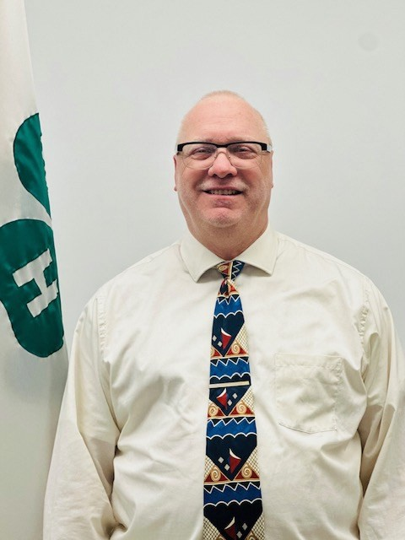
March into 4-H! Spring is right around the corner and it’s the perfect time to start planning and working on 4-H projects! From livestock and gardening to photography, robotics, foods, sewing, and more — there’s something for every interest.

Gary Jones
Allen County 4-H Educator gsjones@purdue.edu
Starting early helps youth set goals, build skills, and feel confi-dent by fair time. Need help choosing a project? Check out the 4-H Family Resources section on our website or reach out to us — we’re happy to help guide you!
The Allen County 4-H Annual Plant Sale Fundraiser has begun! Nelson’s Chicken dinners are available for pre-order this year. Just add the total to the plant order payment. Get
your orders in to the office by March 31st to support our 4-
Hers. All proceeds help fund youth programming, scholarships, and events throughout the year. All pick up information is on
the attached order forms. Spread the word and invite all your friends and family in on this great deal!

Looking for something fun to do this spring and sum-mer? Check out the options for camp, shooting sports and fun block parties. Registrations are coming up fast so don’t blink you might miss out on something fun!
Livestock members don’t forget to sign up for the in-person QLC Training offered in our office in March and May. This class is only $3.
Let’s make March a month of growth, learning, and op-portunity. We can’t wait to see what our 4-H members and vol-unteers accomplish this spring!


4-H INFORMATION
Attention Volunteers! We Can’t Do It Without YOU!!
If you are interested in working with any Allen County 4-H Club as an adult volunteer, you must sign up and complete the trainings in 4-H Online before attending any meetings! New volunteers need to provide 3 references.
This is required by Purdue University for your protection!
PLEASE Complete your training and submit your references for review ASAP!
If you need assistance or have a question please do not hesitate to call the office. We are glad to help!
For returning volunteers, you will have 1 training video to watch. These videos rotate every year. If you are enrolling as a new volunteer, select “New Volunteer.” When you enroll, you will have to select a volunteer type. There will be a dia-gram when you get to this step. Please select the type that most describes you. Enroll here: https://v2.4honline.com If you have any questions about your enrollment and what is due, please call or email, Stephenie at 260-481-6440 or Wooten6@purdue.edu
Ready to Make an Impact? Join Junior Leaders
Are you in grades 7-12 and ready to lead, learn, and create change? Join our Junior Leaders team for an exciting year ahead! This year will center on community service and skill building as the team takes on new projects. There's room
for anyone who is passionate about making a difference in Allen County!
Junior Leaders meet on the last Tuesday of the month @ 6pm. Register for Junior Leaders on https:// www.4honline.com/. For more information or any questions, reach out to
Cheyanne Geideman at cgeidema@purdue.edu


Muzzleloading
∗
∗
∗
Must be an enrolled 4-H member to attend workshops.
The program teaches safe handling of firearms, proper use of equipment, shooting techniques and ethics of good shooters.

Instructors are certified through the Indiana 4-H Shooting Sports Program of Purdue University and the Indiana Department of Natural Resources.
∗
∗
Materials, ammunition and equipment furnished.
Parent or guardian please plan to stay for the entire first meeting.
Orientation Meeting for Parents and Youth April 16, 2026, 6:30 -8:30pm
Workshop Dates:
Meetings will be held Thursday evenings, April 23, 30, May 7, 14, 21 from 6:30-8:30pm at
5198 Co Road 68, Spencerville IN.
Register here: https://springmuzzle2026allen.4honline.com
Archery
Orientation Meeting April 8 @ 6 pm for All at Allen Co Fairgrounds-McComb Bldg Workshop Dates:
April 12, 19, 26, May 3, 10, 17, 31 & June 7 Beginners 12-1:30/Advanced 2-3:30pm at
Allen Co Fairgrounds 2726 Carroll Road Fort Wayne IN
Register Here: https://springarchery2026allen.4honline.com

Make a difference and REGISTER NOW to get certified to be a SHOOTING SPORTS VOLUNTEER!!

MARK YOUR CALENDAR
SAVE THE DATE!!
Allen County 4-H Fair June 23-28, 2026

March 3, | 7-9pm | 4-H Allen County Board Member Meeting @ Extension Office
March 3, 10 | 7:30-8:30pm | Air Rifle Workshop @ Hoagland Community Center
March 4, 11, 18 | 6:30-8:30pm | .22 Rifle Workshop-Winter @ Concordia Lutheran HS
March 30, | 10am & 1pm | 4-H Quality Livestock Care In Person Training (QLC) @ Ext Office
April 2, | 10am-2pm | Spring Break Art Camp (for gr 5-up) @ Johnnie Mae Farm, 2518 Winter
St
April 7, | 7-9pm | 4-H Allen County Board Member Meeting @ Extension Office
April 8 | 6pm | 4-H Archery Orientation @ Allen Co FG McComb Bldg
April 10-12, or Sept 11-13, |  | Allen Co 4-H Shooting Sports Volunteer Certification Camp
April 12, 19, 26, |  | 4-H Archery Workshop @ Allen Co Fairgrounds 2726 Carroll Rd
 |  | (Beginners 12-1:30pm & Advanced 2-3:30pm)
April 16, | 6:30-8:30pm | 4-H Muzzleloading Orientation-Spring @ 5198 CR 68, Spencerville IN
Apr 23, 30 | 6:30-8:30pm | 4-H Muzzleloading Workshop-Spring @ 5198 CR 68, Spencerville IN
April 25 | 1-3pm | Spring Into Art Block Party @ Johnnie Mae Farm, 2518 Winter St
May 3, 10, 17, 31 |  | 4-H Archery Workshop @ Allen Co Fairgrounds 2726 Carroll Rd
 |  | (Beginners 12-1:30pm & Advanced 2-3:30pm)
May 5, | 7-9pm | 4-H Allen County Board Member Meeting @ Extension Office
May 7 | 5-8pm | Flower and Nelson chicken dinner sale pickup- Thursday
May 8 | 9-12am | Flower only pickup- Friday
May, 7, 14, 21 | 6:30-8:30pm | 4-H Muzzleloading Workshop-Spring @ 5198 CR 68, Spencerville IN
May 18, | 6:30pm | Quality Livestock Care In-Person Training @ Extension Office
June 7 |  | 4-H Archery Workshop @ Allen Co Fairgrounds 2726 Carroll Rd
 |  | (Beginners 12-1:30pm & Advanced 2-30pm)


It is the policy of the Purdue University Cooperative Extension Service that all persons have equal opportunity and access to its educational programs, services, activities , and facilities without regard to race, religion, color, sex, age, natural origin or ancestry, marital status, parental status, sexual orientation, disability or status as a veteran. Purdue University is an Affirmative Action Institution. This material may be available in alternative formats.


Workshops/Meetings
Club Meetings
Perry Boosters Club Meeting @ FG, 6:30-8pm, 3/12, 4/16, 5/21, 7/16, 8/20, 9/17, 10/15 (tentative) 11/19, 12/17
Marion BG’s Club Meeting @ Hoagland Pavilion, 6:30-8pm, 3/26
Aboite Homesteaders Club Meeting 3/22 1-2p @St Joe Xmas Tree Farm, 4/26 3-4p @Van Hoozen Park,
5/17 3-4p @Van Hoozen Park, 6/13 9-10:30a @ FG, 6/23 TBD, 6/28 4p @ FG
Allen County Dog Club, meets every Monday, March 2nd—June 1 (except May 25th) 6:15-7:15 Obedi-ence/Showmanship- 7:30-8:30 Intro to agility/open time
Horse & Pony Outdoor Practice Meeting @ FG, every Thursday April 30th--June 18th and Wed, June 17th @ 6:30-8:30p

Livestock Meetings
Saddle Bums Club Meeting @ Ext Office 6:30-8:30, 3/19, 4/23
Horse & Pony Club Leader Meeting @ Ext Office 7-9, 3/17, 4/21, 5/19, 6/16, 7/21, 8/18, 9/15, 10/20, 11/17, 12/15
Three Rivers Rabbit Raisers Meeting 6:30-8, 3/5@Ext Office, 4/16@FG, 5/11@FG, 6/4@FG Swine Committee Meeting @FG 7-9 3/16, 4/20, 5/11
Swine Workshop Meeting @FG 7-8:30, 3/19, 5/14
Beef & Dairy Beef Workshop Meeting @FG Lions Barn 9-12, 3/21 Dairy Cow Meeting @ Ext Office 7:30, 4/13
Weigh-In’s and ID Days
Dairy Beef & Feeder Calf Weigh In @FG Lions Barn 8-10am, 4/11 Goat & Sheep ID Day @FG Lions Barn 6-7:30, 4/30
**ALL MEETING TIMES AND LOCATIONS ARE SUBJECT TO CHANGE.

Follow us on Facebook where we share pictures, important information, and workshop flyers on our page!
Allen County Indiana 4-H: https://www.facebook.com/AllenCounty4H
Have photos to share ? We would love to see them! Please feel free to email allences@purdue.edu with your favorites!

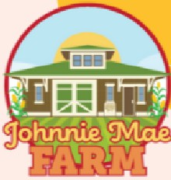

Cost:

$20
Johnnie Mae Farm 2518 Winter St., Fort Wayne, IN


PURDUE
UN IVE RSI TY.
Extension- 4-HYouth Development
Art in the


Garden

MINI 4-H DAV CAMP
Completed Kindergarten - 2nd grade
Choose one day to attend:
July 20 or July 21
Art in the Garden is a one-day creative camp for Mini 4-H'ers where participants will explore nature through hands-on art, planting activities, games, and garden-
themed projects. Campers will paint, plant seeds, create nature crafts, and learn about pollinators.
SIGN UP AND REGISTER NOW
httP-s://AllenMini4HCamP-2026.4honline.com
Purdue University is an Equal Opportunity/EqualAccess University.
�

Allen County 4-H


QLC

g;
PURDUE
UNIVERSITY
utensioo-4-ffl'oottl
�

9:00AM
3:30 PM



Cost is $3 (cash or check only) Due day of the training
In-person Training
9 4001 Crescent Ave, Fort Wayne, IN

March 30, 2026 I At 10 AM
March 30, 2026 I At 1 PM
May 18, 2026 I At 6:30 PM
What to do:
- Follow the link below to 4HOnline.
- Select which training your 4-H member will be attending.
- Hit submit!

Registration :
httP-s://2026allenglc.4honline.com

Have questions? Give us a call at 260-481-6826.
Purdue University is an Equal Opportunity/Equal Access University.

Valentine's Day is over! It is time to celebrate your Mom! or wife, girlfriend, special friend, dog mom, you get the point. Flowers, plants and dinner conveniently located in one place! It is time for the...

Allen County 4-H Annual Plant Sale and
Nelson's chicken dinner fundraiser
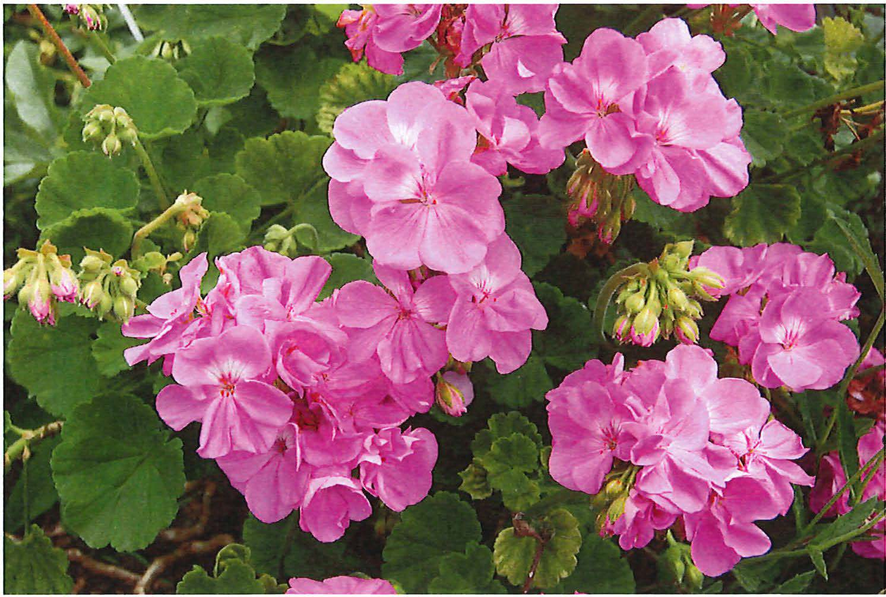
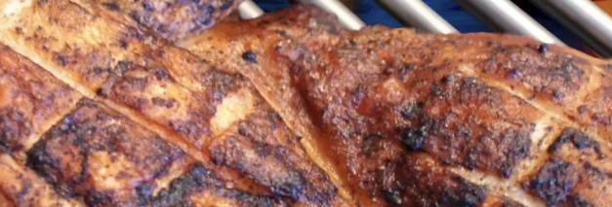


Nelson's chicken order form | (total # ordered) | (total amount owed)
Meal- 1/2 chicken, pit-ato, roll with butter, cookie $15.00 |  | $
1/2 chicken only $10.00 |  | $
Pit-ato only $4.00  Total amount owed |  | $  $
Chicken will only be available on Thursday, May 7 from 5-8 PM

Support Allen County 4-H Clubs, Inc:
Flower pickup will be Thursday, May 7th from 5-8 PM & Friday, May 8th from 9-12 PM.
*Nelson's chicken dinners will ONLY be available Thursday, May 7 from 5-8 PM*

Pick up information: Location is at the Allen County Fairgrounds
(2726 Carroll Road) in the Lions Cattle Barn. Pickup will be Thursday, May 7th from 5-8 PM & Friday, May8th from 9-12 PM. No refunds will be given if you do not pick your order up.

PURDUE
C,__I--'�
UNIVE RS ITY0

I DExetveenlosipomn-en4t-HYouth
QlQ46·

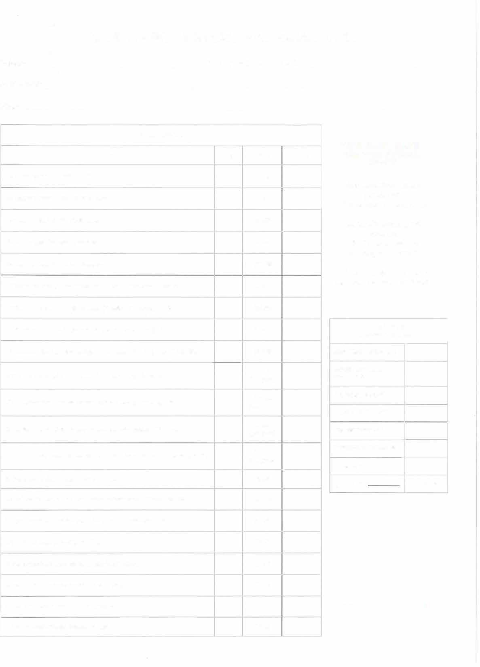



ALLEN COUNTY 4-H PLANT SALE ORDER FORM
NAME: CELL/DAYTIME PHONE: ADDRESS: EMAIL:
ORDER DETAILS
Item | Qty | Price Total
1O' Hanging Basket - Boston Fern |  | $15.00
1O' Hanging Basket - Purple Wave Petunia |  | $15.00
1O' Hanging Basket - Pink Calibrachoa |  | $15.00
1O' Hanging Basket - Red Geranium |  | $15.00
1O' Hanging Basket - Salmon Geranium  11' Premium Combo Hanging Basket (Petunias & Verbena) - Orange |  | $15.00  $18.00
11' Premium Combo Hanging Basket (Petunias & Verbena) - Pink |  | $18.00
11' Premium Combo Hanging Basket (Petunias & Verbena) - Purple |  | $18.00
11' Premium Combo Hanging Basket (Petunias & Verbena) - Red/White/Blue |  | $18.00
4" Pot Geraniums (Must be ordered in single color packs of 9) - Red |  | 12.00  (per pack)
4" Pot Geraniums (Must be ordered in single color packs of 9) - Pink |  | $12.00  (per pack)
4" Pot Geraniums (Must be ordered in single color packs of 9) - White |  | $12.00  (per pack)
4' Pot Geraniums (Must be ordered in single color packs of 9) - Fuchsia (Violet) |  | $12.00  (per pack)
5" Pot Gerber Daisies - Assorted Bright Colors |  | $5.00
13 1/2" Pot Patio Planters - Red Geranium (Geranium, spike & vinca vine) |  | $22.00
13 1/2" Pot Patio Planters - Confetti (Lobelia, petunia & verbena) |  | $22.00
4" Pot Vegetable Plants - Big Boy Tomato |  | $1.50
4" Pot Vegetable Plants - Sweet 1ODs Cherry Tomato |  | $1.50
4" Pot Vegetable Plants - Sweet Green Bell Pepper |  | $1.50
4" Pot Vegetable Plants - Jalapeno Pepper |  | $1.50
4' Pot Vegetable Plants - Banana Pepper |  | $1.50

NOTE: COLOR SHADES WILL VARY BY PLANT VARIETY.

Enclose payment made payable to:
Allen County 4-H Clubs, Inc.

Mail to: Allen County 4-H Clubs, Inc.
4001 Crescent Avenue Fort Wayne, IN 46815

Orders and payment must be returned by: March 31, 2026

GRAND TOTAL (FOR OFFICE USE ONLY)
HANGING BASKETS - $15
PREMIUM HANGING BASKETS- $18
GERANIUM PACK - $72
PATIO PLANTER- $22

GERBER DAISES - $5
VEGETABLE POTS - $7.50
TOTAL DUE
0 CHECK# | □ CASH

A
p
-
APRIL 10 -12, 2026 OR SEPTEMBER 11-13, 2026 ROSS CAMP, TIPPECANOE COUNTY

WHY VOLUNTEER WITH 4-H SHOOTING SPORTS?
To make a difference by helping youth develop confidence, self-discipline, and lifelong skills through a fun, hands-on program!



If you are in need of accommodations or need an interpreter or translator, to attend this program, please contact Gary Jones prior to the meeting at 260-481-6430 or gsjones@purdue.edu.
Purdue University prohibits discrimination against any member of the University community on the basis of race, religion, color, sex, age, national origin or ancestry, genetic information, marital status, parental status, sexual orientation, gender identity and expression, disability, or status as a veteran.
Each individual who wishes to volunteer on behalf on the 4-H Shooting Sports Program in Indiana must:
0 Be an approved Indiana 4-H Volunteer.
° Complete the 4-H Shooting Sports Instruction Certification Training Workshop in the discipline(s) for which you will be teaching youth.
Certification workshops are conducted through a partnership with the Indiana Department of Natural Resources, Hunter Education Division and the State 4-H Shooting Sports Committee.
Registration opens approximately 6 weeks before the workshop is scheduled.
Registrations are handled by the Indiana Hunter Education Association.
There is a fee associated with this training. we are working with the 4-H board to cover this cost.
For more information, open this link:
https:/ /bit.ly/4ausxXU or scan the QR Code.


Registration for the April training begins February 27 and closes around March 30.
Registration for the September training will begin around July 31 and close August 31.

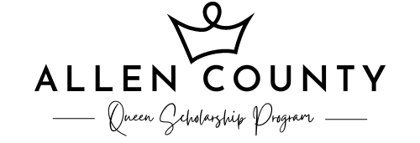

Miss Program
EA RLY D EA D LIN E | A PRIL 1 ST

Calling all young ladies, 17-21, who want to reign over the Allen County Fair. Get VIP access to events and activities, and the chance to represent our county at the Indiana State Fair Queen program in January. Over $4,500 in scholarships will be awarded and a crazy amount of prizes! Learn new skills, make memories and build confidence. Contestant packets are out and the early deadline is April 1st. The program will be on Sunday, April 26th at 5 PM in the Exhibit Building at the Allen County Fairgrounds.

Little Program
O PEN TO FIRST 2 5 TO EN TER

Too young to participate in Miss Allen County? Consider entering the Little Miss Allen County Program—the feature fundraiser of the Allen County Queen Scholarship Fund. This program is open to girls aged 2-12, with winners in three divisions. All participants receive great prizes and a crown! Only open to the first 25 who enter. The Little Miss Allen County Program is not a judged pageant; winners are determined on fundraising efforts. Winners become part of the Queen’s Court and will participate in events during the fair and will be awarded many prizes. Entry will open end of April. To be notified email missallencounty@gmail.com. Little Miss Coronation will be on Tuesday, June 23rd, in the Home & Family Arts Building.

M ISSALLENCOUNTY. COM




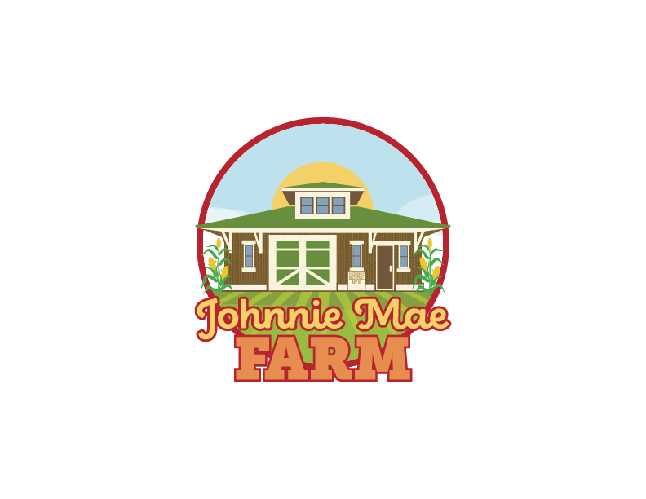

AR

B
APRIL 25, I PM - 3 PM
JOHNNIE MAE FARM! 2518 WINTER ST!FORT WAYNE

Join us for our Spring Into Art Block Party that's bursting with color, creativity, and community spirit! As the neighborhood comes alive with fresh blooms and sunny skies, we're transforming the Johnnie Mae Farm neighborhood into a block party filled with art, hands-on craft stations, and yummy food. Bring your friends and family to explore your creative side, enjoy the FREE cook-out, and celebrate the joy of spring! Whether you're an art lover or just ready to soak up the sunshine, there's something inspiring waiting for everyone!
There is no registration required for this event, just stop on by!
For more information, scan the QR code or visit our site at:
https:/ /bit.ly/4azwPOX
u are in need of accommodations to attend this program, please act Caroline Everidge prior to the meeting at cneverid@purdue.edu 60-481-6826 by April 18.
u need an interpreter or translator, please contact Caroline Everidge to the meeting at cneverid@purdue.edu or 260-481-6826 by April 18.
ue University prohibits discrimination against any member of the ersity community on the basis of race, religion, color, sex, age, onal origin or ancestry, genetic information, marital status, parental
us, sexual orientation, gender identity and expression, disability, or us as a veteran.

APRIL 2, 10 AM
BR A A
GRADES 5TH 6 UP
- 2 PM
A p

REGISTER BY MARCH 26
SCAN THE QR CODE OR CLICK HERE:
HTTPS://BIT.LV/LIASJUVL

Spring Break Art Day Camp is here!

Youth will experiment with four different art mediums, try new techniques, and create artwork they'll be proud to take home.

Spots are limited for this FREE event - let creativity lead the way this spring!
If you are in need of accommodations to attend this program, please contact Caroline Everidge prior to the meeting at

260-481-6826 or cneverid@purdue.edu by March 26.

If you need an interpreter or translator, please contact Caroline Everidge prior to the meeting at 260-481-6826 or cneverid@purdue.edu by March 26.
Purdue University prohibits discrimination against any member of the University community on the basis of race, religion, color, sex, age, national origin or ancestry, genetic information, marital status, parental status, sexual orientation, gender identity and expression, disability, or status as a veteran.

JOHNNIE MAE FARM
2518 WINTER ST, FORT WAYNE, IN
LEARN MORE AT
PUEXT.IN/ALLEN

