Mini Utility Goat
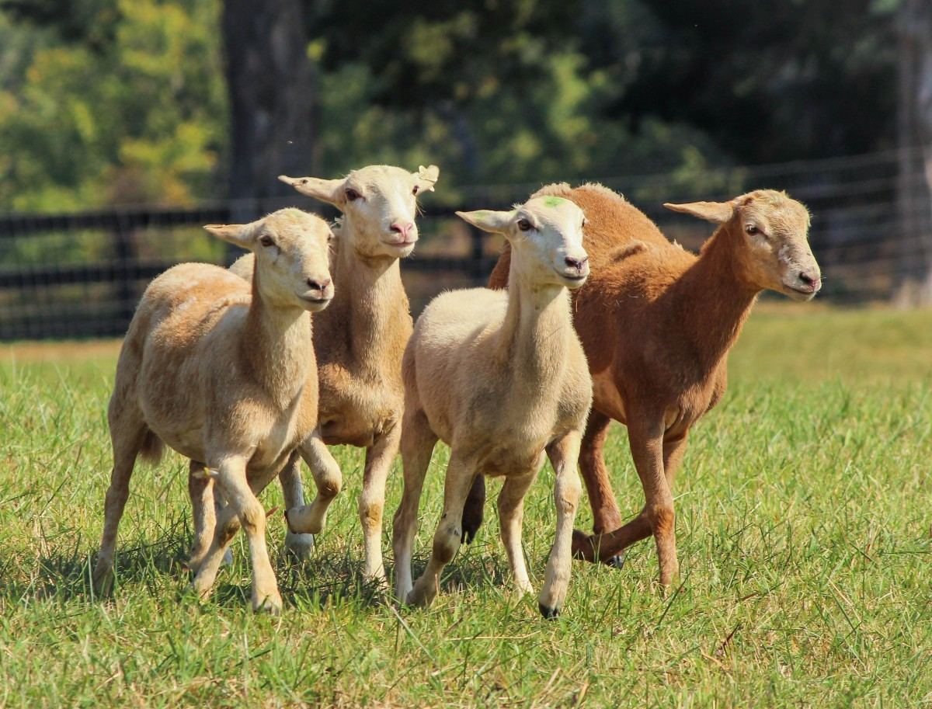

Kindergarten, 1st and 2nd Grades

The Purdue University Cooperative Extension Service is an Affirmative Action, equal access/equal opportunity institution.

Dear Parent:

As a Mini 4-H parent, your job will be to guide and encourage your child through the activity. It is highly suggested that you do not complete the activities for them. Instead, help them, guide them, work with them, and let them do all that they possibly can. The 4-H motto is “Learn by doing”… and is the best educational tool that we can provide for youth.

It is the policy of the Purdue Extension Service that all persons shall have equal opportunity and access to its programs and facilities without regard to race, color, age, sex, religion, handicap, or national origin.

Welcome to Mini 4-H! You are now a member of the
4-H family. Mini 4-H’ers have lots of fun. There are many activities for you to explore. You can try new things. You can share it with your friends and family.

Mom, Dad or another adult can help you with your project, and you can bring your project to the 4-H fair. Many people will be able to see what you have done. You will receive a ribbon made just for Mini 4-H.

Things to learn –

The 4-H Symbol: A four leaf clover with an H in each leaf

4-H Colors: Green and white

The 4-H Motto: To make the best, better.

The 4-H Pledge: I pledge my Head
for clearer thinking;
my Heart for greater loyalty;
my Hands for larger service;
and my Health for better living
in my club, my community,
my country and my world.



Mini 4-H Goat

Welcome to the Mini 4-H Goat project! You are going to learn a lot of exciting things about goats! Did you know that a young goat shares the same name that you are called at times? Have you ever tasted goat milk? Did you know that the goat is related to sheep? Do you know what a goat eats? You will learn the answers to all of these questions in the Mini 4-H Goat project. Goats are a great project for young people to show. Here are a few reasons to raise and show goats.

1. Goats are easy to handle .

2. Goats are gentle and friendly.

3. Goats are smart.

4. They don’t cost much to feed.

5. They need very little space in which to live.

6. Goats do not need very much equipment.

What Will I Do?

To complete the project, you will show a goat at the Hancock County 4-H Fair. The goat must belong to a 4-Her that is enrolled in the traditional 4-H Goat project. If you know a 4-Her that has a goat at the fair, ask them if it is okay for you to show their goat in the Mini 4-H Goat Show. Due to space limitations and health requirements, we cannot allow a Mini 4-Her to bring a goat that they may own.

In Mini 4-H, you must use a collar when showing a goat. 4-Hers will have a collar for you to borrow. All goats shown in the Mini 4-H Goat Show cannot have horns.

You will be divided into classes by your grade. There will be no more than seven Mini 4-Hers in a class. When your class number is called, you will enter the ring with your goat. The judge will tell you where he or she wants you to set up your goat in the show ring. The judge may ask a question or two about the Goat project. Do not get scared if you don’t know the answer. The judge will tell you the answer. Learning is what Mini 4-H is all about!

Doe, Buck, Wether or Kid?

At the start of the Mini 4-H Goat project book, it was mentioned that sometimes, you and a young goat share the same name. Can you guess what that name is? A kid!!!! Goats are called kids until they are old enough to become a mother or a father.

A mother goat is called a doe. People that raise goats select does to keep in their herd to breed. A herd is a group of goats. A female goat becomes a doe around the age of 12 months.

A buck is a male goat. It is the father of the kids or young goats.

A wether is a male goat that has been castrated. Wethers are market animals. When they get to be 100 -130 pounds, they are taken to market and sold for their meat.

What is the difference between a goat and a sheep? A goat’s tail is shorter. If a goat were allowed to grow horns, they would grow upward, back and out. A sheep’s horns are spirally twisted. Goats and sheep are cousins.

What Do Goats Eat?

Goats are ruminants, which means they chew roughage, like hay. They have four compartment stomachs. You have only one stomach. A goat needs four stomachs to digest or break down all of that roughage they eat.

Have You Ever Tried Goat’s Milk?

Goat milk is easier for people to digest than cow’s milk. It is often given to babies that cannot tolerate cow’s milk. Have you ever seen a baby that spits up a lot? It is possible that the baby’s stomach cannot break down the cow’s milk. Goat milk is easier on a baby’s stomach. It is also higher in calcium and other nutrients important for your health.

Most people in our country depend upon cows for milk. People in many other parts of the world depend on goats for their milk. Goats were very important to the first settlers in the United States. Even when there was not much food for the goats to eat, they still were able to produce milk for the settlers. If it were not for the goat, our relatives might have not been able to survive.



In The Show Ring

When you show a goat in Mini 4-H, you must use a collar. The collar will help you lead the goat.

The most important thing there is in showing a goat is to watch the judge. He may tell you to take your goat to another spot in the ring. If you don’t keep eye contact with him, you might miss the change to place your goat higher in the class.

Hold the head of the goat in a normal position or slightly higher. Try to keep the goat between the judge and you. You do not want to stand between the goat and judge because the judge will not be able to see your goat. This will take a lot of practice.

Sometimes a judge will ask a few questions. You might try and learn where the udder, loin, rump, withers and flank are on your goat. Other common questions that may be asked are: What is the weight of your goat? Male or Female? Breed? Age? What does a goat eat?

Do not worry about knowing all this information when you are in Kindergarten or 1st grade. Try to know most of it by the time you are in 2nd grade. If you can answer all these questions by the time you are in 3rd grade and ready to join 4-H, you will be a pro!

Breeds of Goats

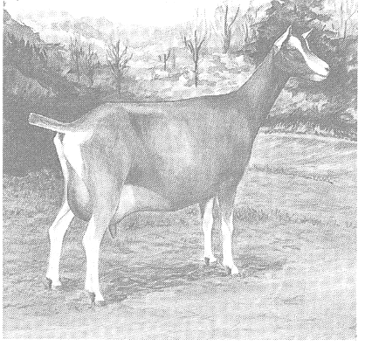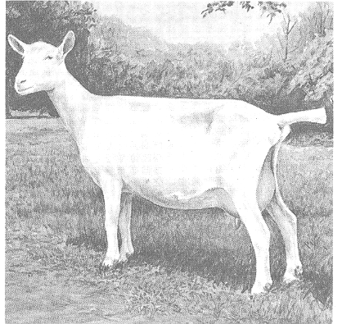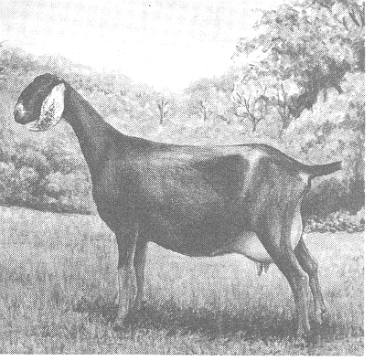
Toggenburg Saanen Nubian

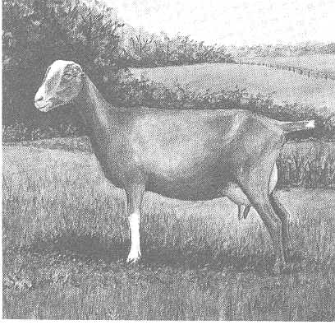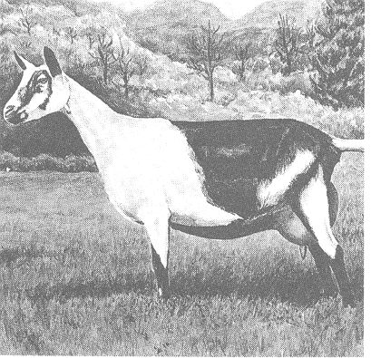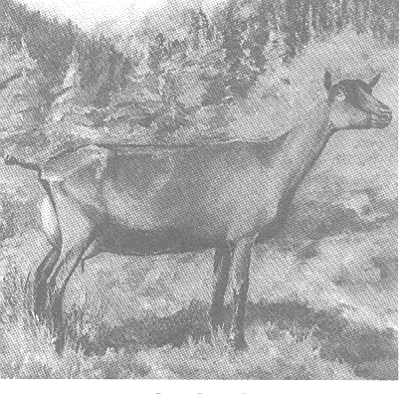
LaMancha French Alpine Oberhasli

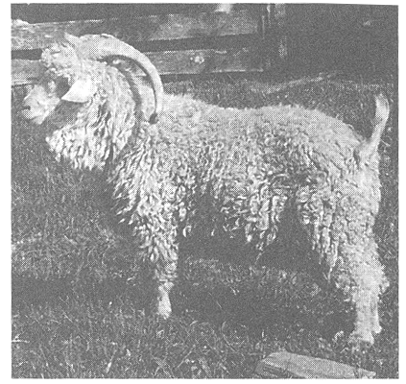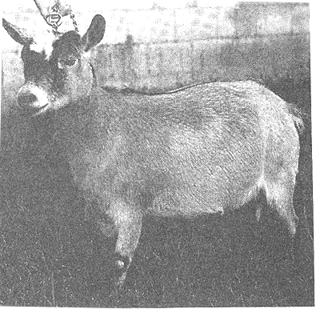
Angora Pygmy

Parts of a Live Goat
Become familiar with the parts of your goat

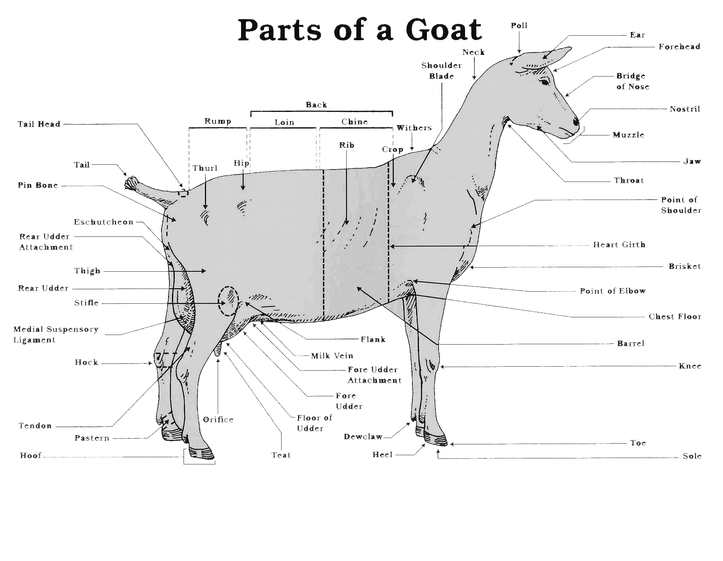

Record Sheet
Mini Utility Goat
20_____
Name: ___________________ Grade: ____

I chose to exhibit: ______________________________________________
I Learned: ______________________________________________________________________________________________________________________________________________________________________________________________________________________________________
My favorite part of Mini 4-H this year was: __________________________________________________________________________________________________________________________________________
List who helped you with your project: __________________________________________________________________________________________________________________________________________

