Mini 4-H Livestock Show Dress Guide

As you prepare for the 4-H Fair and exhibiting animals there are a few things you need to take into consideration. This guide is meant to assist you in selecting your outfit to wear in the show ring. You are presenting yourself to the judge and you want to give a good impression by being professional and presentable. In general all exhibitors and their clothes should be clean and neat, hair combed. Don’t chew gum or wear a baseball hat. You also want to think about safety when selecting your outfit.

Sheep and Swine Show
Tops | Button down shirts, golf shirts or shirts with a collar. It is recommended to tuck shirts in when exhibiting livestock animals.
Bottoms | Jeans or long pants
Shoes | Closed toe shoes are a must. Work Boots, Cowboy Boots, Tennis Shoes to protect feet are preferred, if possible.
Belt | Belts are recommended.
What Not to Wear | It is suggested exhibitors not wear tank tops, midriffs, halter tops, baggy pants, tops with spaghetti straps, shorts, cut offs, or open toed shoes.  No clothing should be worn by an exhibitor that identifies farm name and/or breed during a judging competition.

RECOMMENDED
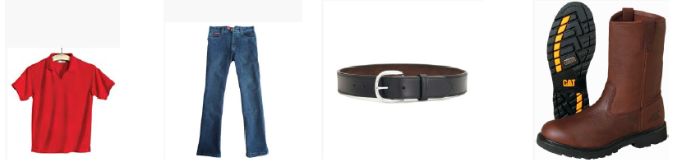

NOT RECOMMENDED
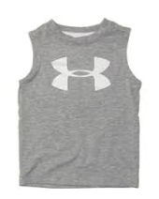

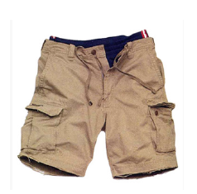
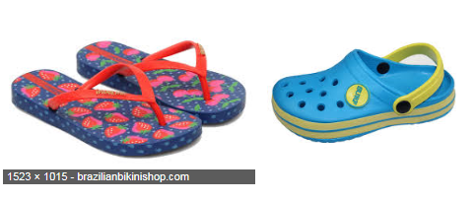

Rabbit Show
Tops | White lab coat or a white button down shirt that you can wear as a lap coat (protects member’s arms). Nice t-shirt can be worn under lap coat.
Bottoms | Jeans or long pants
Shoes | Closed toe shoes are a must. Work Boots, Cowboy Boots, Tennis Shoes to protect feet are preferred, if possible.
What Not to Wear | It is suggested exhibitors not wear jewelry, tank tops, midriffs, halter tops, baggy pants, tops with spaghetti straps, shorts, cut offs, or open toed shoes.  No clothing should be worn by an exhibitor that identifies farm name and/or breed during a judging competition.

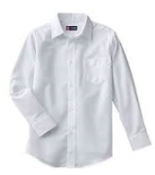
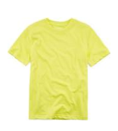
RECOMMENDED
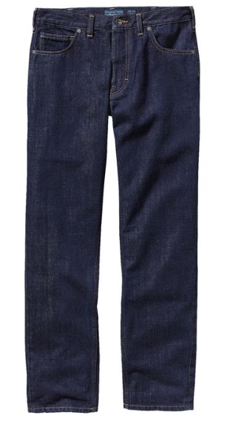

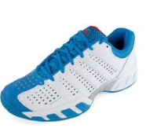

NOT RECOMMENDED
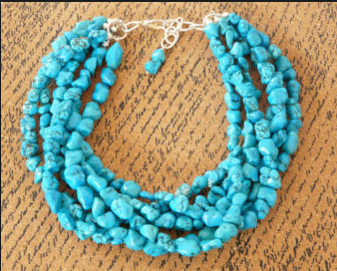
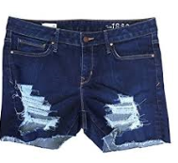
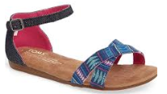

Sources:
Recommended 4-H Livestock Show Attire, Purdue University Extension https://goo.gl/c8kvkW
Ferry County 4-H Member Appearance Guide, Washington State University
http://extension.wsu.edu/ferry/wp-content/uploads/sites/4/2014/02/2014-Fair-Dress-Code1.pdf

June2017

