- Name the Gait

Which gait is the foundation gait?

A rapid, two-beat, diagonal gait is the

An easy, rhythmical, three-beat gait is the

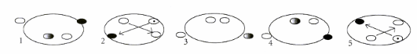
- More naming Gaits

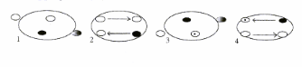

- Please answer the following questions.
How much forage should a horse get every day?

What factors need to be considered when deciding on the rations for your horse?

How much feed will the average horse eat in a day?

What are the four factors that will affect the best ration you give your horse?

What is the cheapest source of the basic nutrients that are given to horses?

