- Determining a Horse’s Age
Use the box above the pictures with ages listed to match them with the correct image of the horse’s teeth.
1 Year Old 4 Year Old
7 Year Old 21 Year Old

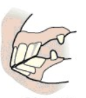
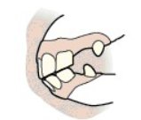
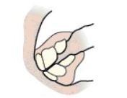
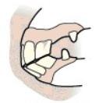

- Match the age with the description of a horse’s teeth

Cups worn from lower intermediate incisors 5 years old
Cup worn from all incisors, upper and lower 7 years old
Smooth mouth; no cups 9 years old
Full mouth; cups in all incisors; canines erupt 11 years old
Cups worn from upper central incisors; dental star 12 years old
appears on lower centrals & intermediate incisors

- Please answer the following questions about the care of teeth

What complications may arise from a horse with sharp points on the outside of the upper and inside of the lower pre-molars and molars?

Who can perform the floating procedure on horses?

What are wolf teeth?

4. Determine whether the following statements are True or False. If false, please explain why

T F Using a nail is the best way to hang your halters and bridles.

T F Gates need to be no larger than 4 ft. high and 6 ft. long.

T F A double overhand knot is also called a blood knot

T F Do not leave a rope halter on your horse when you are not using it.

