- Parts of a Horse 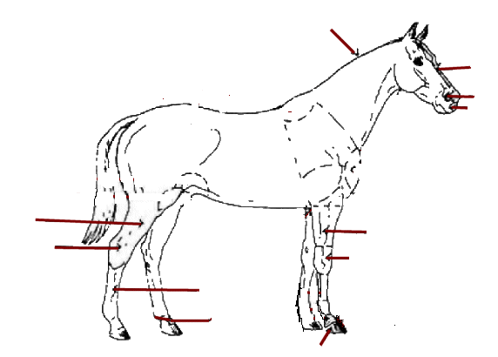
4
1
7
6
5
3
2
11
10
9
8

Place the number from the above picture with the matching body part.

Back Flank Throat Latch
Buttocks Forearm Nostrils
Crest Gaskin Hock
Croup Heart Girth

2. Match the coat colors with the correct description

Roan Has irregular patches in more than one color
Bay White intermingled with one or more based colors.
Paint This horse is a mixture of red and yellow/brown
Brown The body color can range from light yellow to bright copper.
Palomino This color of horse is made up of both brown and black hair and
the mane and tail are always dark.

3. Horse Types and Uses. Fill in the Blank

Horses were originally developed for working livestock on ranches
and for short distance racing

The horse is best known for its smooth, ground-covering, easy-traveling gaits.

What are the four qualities that a good hunter horse should have?
1. 3.
2. 4.

Are the three primary breeds used for racing.

