- Parts of a Western Bridle

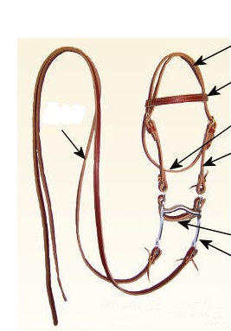

2. Answer the following questions
What should good hay look like?

Most horses consume roughly how much of their body weight in dry feed each day?

What can you do to make sure your barn is free of mice and rats?

Why do you NOT want to use a nail to hang your halters and bridles on?

3. Decide whether the following statements are True or False. If false, please explain why.

If your horse refuses to eat its feed, it is usually a sign that they are not hungry. True/False.
When feeding pure alfalfa hay it is important to balance the Calcium to phosphorus ratio. True/False.
Do not feed or water when your horse is ill. True/False.

A thousand pound mature horse ridden of 2 hours a day should be fed 5 pounds of hay and 15 pounds of grain daily. True/False.

