- Parts of the Western Saddle
Use the word bank to place the correct part next to the appropriate arrow.

Horn Skirt Pommel Seat Finder Cinch
Cantle Seat Jockey Stirrup Latigo Rear Dee Ring

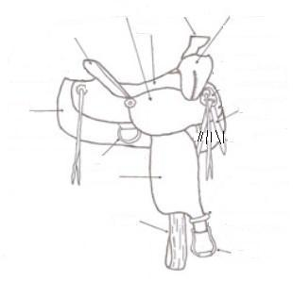

- Please answer the following questions
How many times a day does a healthy horse defecate? Urinate?

How can you determine a horses heart rate if you do not have a stethoscope?

Prevention of parasite infection is bases on what three things?

How can dewormer be given to a horse?

Horses should be dewormed in the at least hours before placing them out on clean pastures.

- Determine whether the following statements are True or False. If false, please explain why.

T F A new born foal will have a heart rate between 90 and 130 bpm.

T F The normal respiration rate for a resting horse is 8 to 16 breaths per minute.

T F The normal temperature of a horse is 101.3.

T F The heart rate of a horse can be taken by placing a stethoscope on the left side of the horse’s body, directly behind the elbow.

