- Parts of the hoof
Match the number on the hoof structure with the appropriate name of the part.

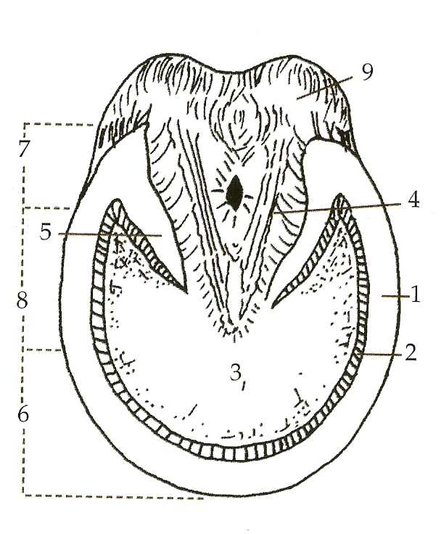

_____Bulb

_____Frog

_____Heel

_____Bar

_____Sole

____Quarter

_____Toe

_____White Lane

_____Wall

- Determine whether each statement is True or False.

T F Putting shoes on a horse is not always best for them.

T F If a horse wears shoes for too long of a time period the hoof can grow beneath the shoe.

T F In icy and muddy conditions shoes do not help the horse have more traction.

T F The normal temperature of a horse is 101.3 degrees.

T F The heart rate of a horse can be taken by placing a stethoscope on the left side of the horse’s body, directly behind the elbow.

3. Answer the following questions.
How can you determine a horses heart rate if you do not have a stethoscope?

List five signs that could indicate your horse is sick.

What is the normal resting heart rate of a mature horse?

