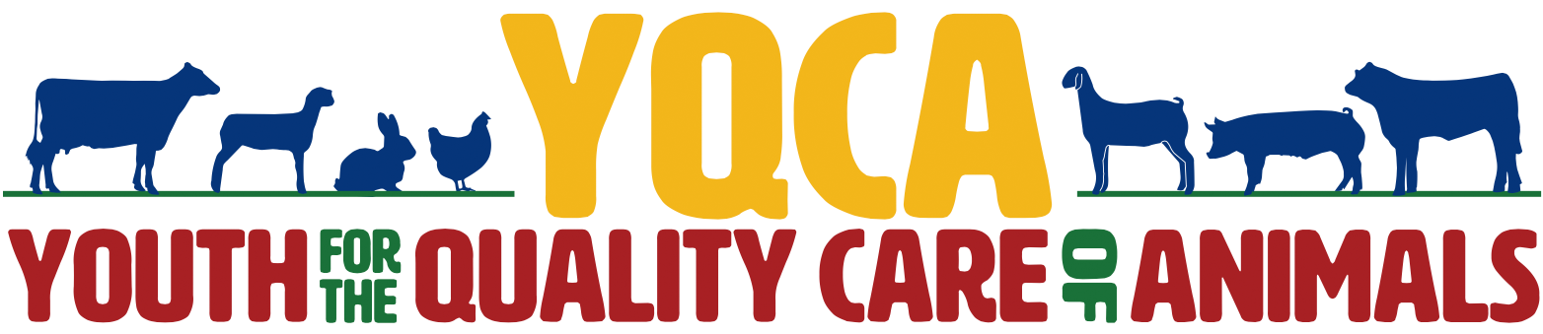
Boone County
Lebanon, Indiana
YQCA TRAINING
April 13, 2021; 6:00pm  Witham Pavilion, Exhibit Hall  May 12, 2021; 6:00pm  Witham Pavilion  Meeting Rooms 1 &2  May 19, 2021; 6:00pm Witham Pavilion  Meeting Rooms 1 & 2  All trainings will be held at the  Boone County 4-H Fairgrounds | Please register BEFORE you get to the training!  To sign up for a training visit  www.yqca.org  Create your YQCA Account by logging in with the same info as your 4-HOnline profile!  In-person trainings are $3! (Online trainings are available. See email from Pandora with more info)  Call the Extension Office if you have questions!

The Youth for the Quality Care of Animals (YQCA) is an exhibit requirement for any 4-H member in the following projects: Beef Cattle, Dairy Cattle, Feeder Calf, all Goats, Poultry, Rabbits, Sheep, and Swine. Members only need to complete the training once for the year (NOT once per species). Members may attend any of the above meetings OR a YQCA training in another county OR complete the training online. If you need to request special accommodations for the trainings, please contact the Boone County Extension Office at least a week before the event.


Purdue Extension – Boone County

1300 E. 100 S. Lebanon, IN 46052, 765-482-0750

Visit www.yqca.org to sign up for a training today!

Additional YQCA Training Dates in Other Counties

County Dates
Hancock *  Sarah Burk- Exhibit Hall  620 Apple St.  Greenfield, IN 46140  317-462-1113 | March 10: 6:00pm  March 15: 12:00pm  March 18: 5:30pm
Clinton *  1111 S. Jackson St  Frankfort, IN 46041  765-659-6380 | March 31  April 28  May 26
Hendricks *  Hendricks County 4-H Fairgrounds  Danville  317-745-9260 | April 29: 6:30pm  May 27: 6:30pm  June 25: 2:00pm & 5:30pm
Hamilton *.  Annex  Hamilton County 4-H Fairgrounds  2003 Pleasant ST, Noblesville, 46060  317-776-0854 | May 18: 6:30pm  June 23: 6:30pm
Morgan*  Morgan County Administration Building  Lucille Sadler Room 229, Martinsville  765-342-1010 | April 8: 6:30pm  May 20: 6:30pm  May 25: 6:30
Montgomery *  4-H Building  400 Parke Ave, Crawfordsville  765-364-6363 | April 12: 6:00pm  May 25: 6:00pm  June 2: 12:00pm  June 28: 6:00pm  July 7:6:00pm (Exhibit Hall)  July 12: 12:00pm
Tippecanoe  3150 Sagamore Parkway South  Lafayette, IN 47905  765-474-0793 | March 17: 6:00pm  March 23: 7:30pm  April 12: 6:00pm  April 16: 7:30 pm  May 3: 6:00pm  May 5: 7:30pm

