Carroll County 4-H

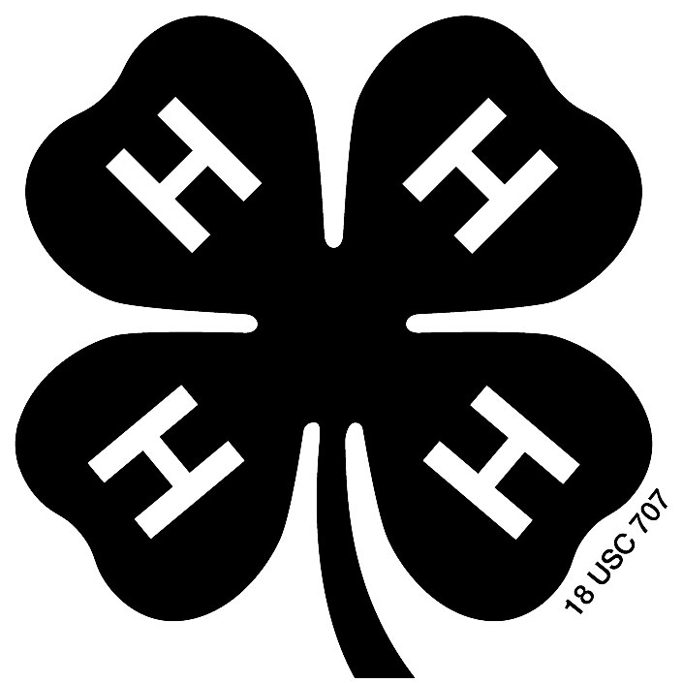 Llama & Alpaca

Costume Class

Champion Exhibitor #___________

Comments__________________________

Reserve Exhibitor #_____________

Comments__________________________

Third Place Exhibitor #__________

Comments__________________________

Fourth Place Exhibitor #_________

Comments__________________________

Fifth Place Exhibitor #__________

Comments_______________________

Sixth Place Exhibitor #_________

Comments_______________________

SL- Short lead LL- Loose lead TL- Tight lead R-Refusal
OC-Off course IO- Incomplete Obstacle LP-Loose Pack
H- Hesitation C- Contact F- Fall LH/TH- Loose/tight halter

Carroll County 4-H

Llama & Alpaca

Driving Class

Champion Exhibitor #___________

Comments__________________________

Reserve Exhibitor #_____________

Comments__________________________

Third Place Exhibitor #__________

Comments__________________________

Fourth Place Exhibitor #_________

Comments__________________________

Fifth Place Exhibitor #__________

Comments_______________________

Sixth Place Exhibitor #_________

Comments______________________

SL- Short lead LL- Loose lead TL- Tight lead R-Refusal
OC-Off course IO- Incomplete Obstacle LP-Loose Pack
H- Hesitation C- Contact F- Fall LH/TH- Loose/tight halter

