

In this issue
4-H & Youth Development
- 4-H Deadlines (pg. 2)
- Setup & Tear Down (pg. 2)
- Mini 4-H (pg.2)
- 4-H Exhibit Hall (pg. 3)
- Animal Shows (pg. 3)
- Other Fair Information (pg. 4)
- 4-H Activities (pg. 4)
- 4-H State Fair (pg. 4)
- Fair Schedule (pg. 5)
Health and Human Sciences
- Extension Homemakers (pg. 6)
- ServSafe (pg. 7)
- Nutrition Podcast (pg. 7)
- Caring for your Canners (pg.8)
- What is HHS (pg. 8)

Agriculture, Natural Resources, and Horticulture
- Upcoming Events (pg. 9)
- Wild About Nature Series
(pg. 9)
- Pesticide disposal day (pg. 10)
- New homestead rules (pg. 11)
- Drought tolerant flowers (pg.11)
Office contact information:
4259 N Purdue Rd.
Vincennes, IN 47591

Phone: 812-882-3509
Fax: 812-882-3537

Website: www.extension.purdue.edu/knox

Email: knoxces@purdue.edu

It doesn’t seem like we can be in July already but here we are. July is a busy month between vacations, the 4th of July Celebration, and of course the fair.
4-H families make sure to review your fair newsletter and the deadlines and information about fair in this newsletter.
Tonya (Health and Human Science Educator) will be offering a ServSafe class coming in July. I am working with Purdue specialists to offer a vegetable field day in August so you can learn all the latest research being conducted here in Vincennes by Purdue.

If you have 4-H, health, nutrition, food safety, agriculture, natural resource, or gardening questions feel free to call us at 812-882-3509.

Valerie Clingerman Extension Educator
Agriculture and Natural Resources/County Extension Director


Pictures courtesy: Adobe Stock
Youth Activities at this year’s
Knox County Fair!
- July 28 – 29: 4-H games & activities around Livestock Arena at 2:00 pm.
- July 29: Watermelon Day from 6:00 – 8:00 pm
Seed spitting contest, biggest bite contest, face painting and tattoos, crafts in the Open Class Building and more!
- July 30: Kiddy Day from 5:00 – 8:00 pm
- July 31: Ag Olympics, Color Me Green 4-H Dash, then Water Slide starts at 11:00 am around the Livestock Arena and ends around 2:00 pm.
- Every Day: grab a fair passport from the Farm Bureau Building, roam the grounds for the clues and return it for candy!
4-H & Youth Development
Mitch Wagoner
Extension Educator – 4-H Youth Development
mwagoner@purdue.edu
4-H Fair Schedule

Deadlines:
- July 1: Creative Writing and Genealogy projects due to Extension Office by 3:00pm (hard copies or email to Mitch)
- July 1: State Fair 4-H early bird registration deadline.
  - State Fair website: https://exhibitorscorner.indianastatefair.com/
- June 30: Livestock penning paperwork due to the Extension Office by 4:00 pm.
- July 20-25: General Record Sheets and Livestock Record Sheets can be turned into the Extension Office (@ Fairgrounds) to receive your 4-H Fair Pass.
- July 15: Fair Entry closes.
- July 30: Auction animals need to be identified, and auction pictures are due by 12:00 pm.

4-H Fair Set-up & Tear Down:
- June 25: Horse & Pony clean-up will be announced during a Horse & Pony Club Meeting.
- July 18: Rabbit members will be hanging cages at 8:00 am.
- July 18: Livestock cleanup day at the Fairgrounds at 8:00 am.
- July 20: building setup at the Farm Bureau Exhibit Hall at 6:00 pm for ALL Clubs!
- August 2: Building tear down at the Farm Building Exhibit Hall at 6:00 pm for ALL Clubs.

Mini 4-H Information
- Mini 4-H building projects can be turned in either day during judging on Wednesday, July 22 from 5:00 – 8:00 pm or Saturday, July 25 from 8:00 – 11:00 am.

4-H Scavenger hunt all week to win candy!!
You can pick up your new passport book each day at the 4-H Exhibit Hall and go to different locations to get your booklet hole punched.

Farm Bureau Exhibit Hall Information
- July 22: In-person non-perishable project judging at the Farm Bureau Exhibit Hall from 5:00 to 8:00 pm.
- July 25: In-person perishable and sewing project judging at the Farm Bureau Exhibit Hall from 8:00 to 11:00 am.
- July 27 – August 1: Farm Bureau Exhibit Hall hours to the public
  - July 27 from 11:00 am to 1:00 pm & 4:00 to 10:00 pm.
  - July 28 from 8:00 am to 1:00 pm & 4:00 to 10:00 pm.
  - July 29, 30, 31 from 11:00 am to 1:00 pm & 4:00 to 10:00 pm
  - August 1 from 4:00 to 9:00 pm
- August 1: Building projects released from 9:00 to 11:00 pm
- August 2: Building projects released from 5:00 to 6:00 pm.

Animal Show Information:
- July 26: All animals may arrive on the grounds from 8:00 am to 4:00 pm
- July 26: Official check-in for ALL animals from 4:00 am to 9:00 pm. All animals must be in the barn by 9:00 pm.
- July 26: Dog Agility at the Club meeting location starting at 6:30 pm
- July 27: Poultry Show starts at 8:00 am at the Poultry Barn.
- July 27: Rabbit Show in the Show Barn Arena will start at 9:00 am.
- July 27: Horse and Pony Contest Show starts at 4:00 pm at the Horse & Pony Arena.
- July 27: Livestock Costume Contest at 5:00 pm at the Show Barn.
- July 28: Swine Show starts at 8:00 am at the Show Barn.
- July 28: Dog Obedience & Showmanship starts at 8:30 am in the Old Commercial building.
- July 28: Sheep Show starts at 4:30 pm at the Show Barn.
- July 29: Beef show starts at 9:00 am with the Dairy Show between the Heifer and Steer Show at the Show Barn.
- July 29: Cat Show starts at 3:00 pm in an A/C building.
- July 29: Goat Show starts at 4:30 pm at the Show Barn.
- July 30: Horse and Pony Show starts at 9:00 am at the Horse & Pony Arena.
- July 30: Llama and Alpaca Show starts at 9:00 am at the Show Barn.
- July 30: Round Robin starts at 7:00 pm at the Show Barn.
- July 31: Horse and Pony Show starts at 9:00 am at the Horse & Pony Arena.
- July 31: 4-H Livestock Auction starts at 5:30 pm at the Show Barn.
- July 31: After the 4-H Auction at 10:30 pm Livestock released.

Other Fair Information:
- July 24: Consumer Clothing Judging at 6:00 pm and Fashion Revue at 7:00 pm at the First Church of God in Monroe City.
- July 20: Extension Office moves to the Fairgrounds.
- July 30: 4-H Premium money will be available to be picked up starting at 4:00 pm.
- July 30: 4-H Parade of Champions for the Grand & Reserve Grand Champions for Exhibit Hall, Dog, & Cat starts at 3:00 pm
- July 31: 10 Year Member Awards starts at 5:00 pm at the Show Barn.

Youth Activities not during shows:
- July 28 - 29 4-H games & activities around Livestock Arena at 2:00 pm.
- July 29: Watermelon Day from 6:00 – 8:00 pm
- July 30: Kiddy Day from 5:00 – 8:00 pm
- July 31: Ag Olympics, Color Me Green 4-H Dash, then Water Slide starts at 11:00 am around the Livestock Arena and ends around 2:00 pm.

State Fair Project Information:
- For 2026, The Purdue Extension – Knox County Office will be providing transportation for projects to & from the Indiana State Fair.
- Projects that are big, heavy, fragile, etc. must be transported by the exhibitor. The Extension Office is not taking responsibility.
  - August 3: All projects except Foods & Gardening to be check-in at the State Fair from 8:00 am to 8:00 pm.
  - August 10: Foods & Gardening projects must be dropped off to the Extension Office between 7:30 - 9:00 a.m.
  - Preserved food exhibits will NOT be returned and will be destroyed, including canning jars!
  - August 25: All ribbons, non-animal exhibitor pins, judge’s score cards can be picked up from the Extension Office.

General Information:
- July 3: Independence Day – Office Closed
- October 1: 4-H Enrollment begins for the 2026-2027 program year



Health & Human Sciences
Tonya Short, Extension Educator – Health & Human Sciences
Short43@purdue.edu www.facebook.com/KnoxCoHHS


Extension Homemakers—Updates
Next County Council meeting is July 6th at 10:30 AM in the library sunroom. The group will be planning for their hostess duties for the Spring 2027 District meeting. All hands and ideas are needed. Please plan to attend or contact Darlene Decker or Suzan Morgan.
Club Presidents: If you have activities or announcements to include in the newsletter, get that information to Tonya by the 15th of even numbered months. E.g. Information to Tonya by June 15 for printing in the July-August newsletter.

News from the Knox County Extension Homemakers

An update of recent events for the Knox County Extension Homemakers:
- Spring District meeting in Warrick County was well attended. Mrs. Pat Koch was the special guest speaker telling us her family history with Holiday World.
- May Breakfast was held at Ponderosa with eight members and two guests attending. Helping HIs Hands presented about services offered and resources available to families and communities in times of need.
- Home and Family Conference was held June 15-17 at Nashville, Indiana. Three members attended and will share at the next County Council meeting.
- Members are helping with the Open Class Showcase during the Knox County Fair July 27-Aug 1. Anyone 16 years of age and older can exhibit, no matter where you live. Check out details on the Knox County Farm Fair webpage or follow along on Facebook. https://knoxcountyfarmfair.godaddysites.com/open-class www.facebook.com/KnoxCountyFarmFair/
Invitation to be involved:
- Anyone/Everyone is invited to become an Extension Homemaker. Purdue University Extension provides their knowledge for educational development. Clubs meet in their home or other locations convenient for the members, usually during the day. Contact Darlene Decker or Suzan Morgan for more details. Or contact the Extension Office with any questions at 812.882.3509.

ServSafe Manager courses
ServSafe Manager Certification is an approved training course in the state of Indiana to become a certified food protection manager. This includes anyone who is the food service manager for a restaurant or other business and anyone who uses a shared commercial kitchen.

ServSafe Food Handler is for anyone else who needs basic food safety and food handling training, including home-based vendors, food service workers, volunteers, or others who work with food and only need the basic training. This course is NOT intended for food service managers.
To find and register for upcoming classes, visit https://edustore.purdue.edu/extension-programs.html, choose “HHS Events” then search by keyword, county and/or date. You may also contact Tonya at 812-882-3509 or short43@purdue.edu.

When | Where | Learn more or register at
July 23, 2026 | Vincennes | https://cvent.me/MaWoPb
October 27, 2026 | Washington | https://www.cvent.com/d/kxqvj2

Bite by Bite: Nutrition for Life Podcast

Anywhere you look you can find a magic pill or formula promising to protect your health and transform your body in three easy steps. And many of these claims do have (or at least started with) a speck of valid science. So, how do you cut through all the hype and separate truth from false marketing claims? The truth is, it doesn’t have to be that complicated! Join us as we explore and dissect different fads and trends to discover the real science behind food and nutrition.
Find us on Apple podcasts, Spotify, or anywhere you listen.

Follow us on Facebook and Instagram @BiteByBiteNutritionForLife

Caring for Your Canners
With a few steps you can keep your canners in tip-top shape, so they are ready to use when you need them. I’ve outlined a few important details below.
- Have the gauge of your pressure canner checked annually before the start of canning season. Even a brand-new gauge should be tested. An accurate gauge is absolutely necessary to ensure your food is canned properly.
- Protect your gauge from bumps during transport and storage. Store your canner inside if possible. Do not store your canner with the lid sealed. Store your canner with the lid upside down or right side up on a separate shelf.
- Keep the inside of your canners clean. Use vinegar to remove any hard water build up. Wash and fully dry your canner after each use. This includes vents, weights or petcock. Place crumpled up newspaper in your canner during storage.
- Ensure your vent pipe is clear and the pressure valve moves freely. Replace the gasket if it becomes dry or has visible cracks.
- For water bath canners, they should be large enough that 1-2 inches of water will cover the jars. A tight-fitting lid will minimize water loss during the processing time.
You can find comprehensive guide and check list from University of Idaho. https://objects.lib.uidaho.edu/uiext/uiext3562.pdf
If you have canning questions or would like to have your dial gauge tested, contact Tonya at 812-882-3509.
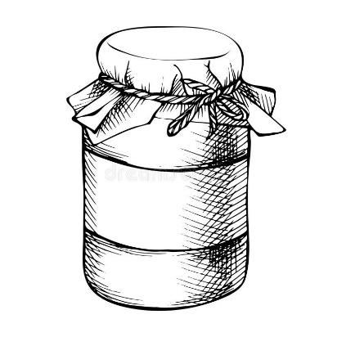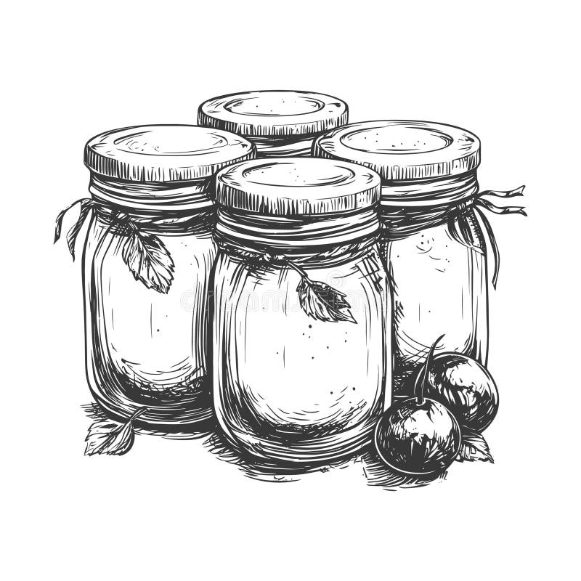Pictures courtesy: dreamstime.com

Agriculture & Natural Resources
Valerie Clingerman-Extension Educator
Agriculture & Natural Resources
clingerman@purdue.edu

**Like Purdue Extension Knox County Ag and Natural Resources on Facebook.
**To receive monthly e-newsletters call 812-882-3509 or e-mail me to be added.

Upcoming Events
Date | Event | Time (Eastern) | Location | Contact info.
August 6 | Wild About Nature Series-Leaves and Trees (see below) | 6pm | Vincennes | Register by calling:  812-882-4316
August 13 | Southwest Purdue Agricultural Center Vegetable Field Day | 8:00am | Vincennes | Register by Aug. 6 at: https://tinyurl.com/SWPACVegFieldDay26
August 18 | Indiana Pesticide Clean Sweep-Pesticide Disposal (see page 10 for details) | 10:00am | Haubstadt | Register at: https://oisc.purdue.edu/pesticide/clean_sweep.html
Sept. 19 | Wild About Nature Series-Birds  (see below) | 10am | Vincennes | Register by calling:  812-882-4316
Sept. 26 | Monarch Madness | TBD | Vincennes | 812-882-8210

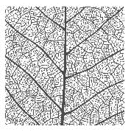
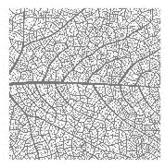
Wild about Nature Series
I am excited to partner with the Knox County Parks Department to offer these hands-on activities about nature. We will have programs monthly from May-Sept. and will be meeting at County Parks.
Adobe Stock
Adobe Stock

Agenda:

July 23-This class has been cancelled.
August 6-Ouabache Trails Brittany Trail, learn about trees and collect leaves to create rubbings.
September 19-Ouabache Trails Nature Center, learn about birds while viewing them and create your own bird feeder to take home.

The May-August programs will be from 6-8pm and the September program will be from 10am-1pm.

Please register with the Parks Department by calling 812-882-4316.

2026 Indiana Pesticide Clean Sweep Project - Pesticide Disposal

WHAT is Clean Sweep?
The Indiana Pesticide Clean Sweep Pesticide Disposal Program designed to collect and dispose of suspended, canceled, banned, unusable, opened, unopened or just unwanted pesticides (herbicides, insecticides, rodenticides, fungicides, miticides, etc.). This disposal service is free of charge up to 250 pounds per participant. Over 250 pounds there will be a $3.00 per pound charge. This is a great opportunity for you to legally dispose of unwanted products at little or no cost.

WHO can participate?
All public and private schools, golf courses, nurseries, farmers, ag dealers, public, cities, towns, municipalities and county units of government or others receiving this notice are eligible to participate.

WHEN and WHERE is Clean Sweep going to be held in 2026?
Each event is 9:00 am to 2:00 pm local time. The closest event will be held in Gibson County on August 18, 2026, at Superior Ag (150 W 1200 S Haubstadt, IN 47639)
HOW do I participate?
Complete the Clean Sweep Pesticide Disposal Participant Form to the best of your ability. It can be found at https://oisc.purdue.edu/pesticide/clean_sweep.html
Tip for the form: Download and open within Adobe Acrobat to complete and submit. The form will not work in web browser view.

Submit your completed form by Friday, August 7, 2026.
Email: cleansweep@groups.purdue.edu
Mail: Office of Indiana State Chemist, Attn: Clean Sweep, 175 S University St. West Lafayette, IN 47907
Fax: 765-494-4331

Additional Information:
- Bring your leak free and safe to transport containers to the collection site.
- DO NOT mix materials.
- Empty pesticide containers will not be accepted. Follow label directions for proper disposal of empty containers
- Bulk containers must be documented on the participant form to be accepted.
Thank you for your interest in the safe and legal disposal of waste pesticides.

Questions:
Contact us by email: cleansweep@groups.purdue.edu
New rules taking effect July 1, 2026 for farm and homestead food sales
In March 2026, Indiana legislators passed House Enrolled Act 1424 which created new rules (IC 16-42-5.4) for products that can be produced and sold to the direct end consumer. This legislation applies to homestead vendors and small farm operators. The Indiana Department of Health (IDOH) has released additional guidance on this regulation. You can learn more by visiting https://ag.purdue.edu/department/foodsci/home-based-vendors.html or you can call our county health department 812-882-8080.
Summer Flower Spotlight – Drought Resistant Edition

Written by: Karen Mitchell, Purdue University

Indiana summers are often hot and dry, creating challenging conditions for many plants. Fortunately, some flowers are naturally suited to these conditions, making them excellent choices for low-maintenance landscapes.
Coneflower – Echinacea spp.
Herbaceous perennial that grows 3 to 4 feet tall in full sun. Blooms from early summer into fall and attracts a variety of bees and butterflies. If left standing through winter, the seed heads provide food for songbirds. Potential problems: Occasionally develop aster yellows or powdery mildew or fall prey to Japanese beetles. Good air circulation and avoiding overhead irrigation can help reduce disease.
Angelonia – Angelonia angustifolia
A heat-loving annual that thrives during Indiana’s hottest months. Plants typically grow 12 to 24 inches tall and produce spikes of purple, pink, white, or blue flowers from late spring until frost. Unlike traditional snapdragons, angelonia continues to perform well through heat and humidity with minimal care. Angelonia prefers full sun and well-drained soil. Its upright growth habit makes it ideal for containers and borders. Potential problems: Root rot may occur in poorly drained soils. Aphids and spider mites can occasionally become problematic during periods of stress.
Yarrow – Achillea spp.
Hardy perennial prized for its fern-like foliage and flat-topped flower clusters that bloom throughout summer. Available in shades of yellow, red, pink, orange, and white, it typically grows 2 to 3 feet tall and thrives in full sun and well-drained soils. Potential problems: Overly fertile soils or excessive irrigation may cause stems to flop. May occasionally develop powdery mildew or stem rot during humid conditions, particularly where air circulation is poor.
Penstemon Beardtongue – Penstemon spp. (Figure 4)
Durable perennial known for its upright growth habit and spikes of tubular, nectar-rich flowers that attract a wide range of pollinators. Growing 3 to 5 feet tall, it performs best in full sun and well-drained soils. Cultivars offer a variety of flower and foliage colors, making penstemon a versatile addition to the landscape. Potential problems: Root rot may occur in poorly drained soils, and excessive fertility can lead to weak stems and reduced flowering.
Sedum – Sedum spp.
Also known as stonecrops, are among the most reliable drought-tolerant perennials for Indiana gardens. Available in both upright and groundcover forms, they offer succulent foliage and clusters of flowers that attract pollinators throughout the growing season. Upright varieties such as ‘Autumn Joy’ provide sturdy stems topped with pink flower clusters that deepen to bronze as the season progresses. Low-growing sedums, including the Indiana native wild stonecrop (Sedum ternatum), spread slowly and work well in rock gardens and borders. Potential problems: Sedums may occasionally develop crown rot in overly wet soils. Slugs can also damage young growth during wet springs.
Tips for Establishing Drought-Tolerant Plants
Will need regular irrigation while their roots become established. Water deeply but infrequently to encourage roots to grow deeper. Applying 2 to 3 inches of organic mulch helps conserve soil moisture and suppress weeds. Choosing plants adapted to the site conditions reduces maintenance and helps create a resilient landscape that can withstand Indiana’s summer heat and periodic drought. To read the full article visit: https://purduelandscapereport.org/issue/26-07/
age form: Adobe Stock


ocust, and poplar are labelled as
Nonprofit Organization
U.S. Postage
PAID
Vincennes, IN
Permit No. 39
Purdue University Cooperative Extension Service
Knox County
4259 North Purdue Rd.
Vincennes, IN 47591

Nonprofit Organization
U.S. Postage
PAID
Vincennes, IN
Permit No. 39


Thank you for your support!
Look inside for Agriculture & Natural Resource, Health and Human Science, and 4-H updates

