

In this issue
4-H & Youth Development
- 4-H Enrollment (pg. 2)
- Fair Dates (pg. 2)
- 4-H Numbers (pg.2)
- State Fair Exhibitors (pg. 3)
- State Fair Exhibitors (pg. 4)
- Upcoming Dates (pg. 4)
Health and Human Sciences
- Extension Homemakers (pg. 5)
- ServSafe (pg. 6)
- Nutrition Podcast (pg. 6)

Agriculture, Natural Resources, and Horticulture
- Upcoming Events (pg. 7)
- Wild About Nature Series
(pg. 7)
- Monarch Madness (pg. 8)
- Crop condition survey (pg. 8)
- Guatemala drone programming (pg. 9)
Office contact information:
4259 N Purdue Rd.
Vincennes, IN 47591

Phone: 812-882-3509
Fax: 812-882-3537

Website: www.extension.purdue.edu/knox

Email: knoxces@purdue.edu

Fairs are wrapped up, school has started, and pumpkin/apple season is here.
As a friendly reminder if you need to pick up fair projects from the office please do so as soon as possible.
Check out all our state fair exhibitors and 4-H enrollment information inside this newsletter. This edition also has upcoming programs for ag and health as well as an overview of the training I helped with in Guatemala. Specialists are also asking for help to identify crop condition across the state and you can find the survey inside.

If you have 4-H, health, nutrition, food safety, agriculture, natural resource, or gardening questions feel free to call us at 812-882-3509.

Valerie Clingerman Extension Educator
Agriculture and Natural Resources/County Extension Director

Changes to Extension

We are experiencing many changes at the Purdue Extension-Knox County Office.

*Tonya Short our Health and Human Sciences Educator recently left Extension to pursue a career teaching at Vincennes University. If you see her make sure to congratulate her on her new role.

*Many of you have heard that Purdue Extension is transforming and adopting a more regional model. To learn more please visit: https://extension.purdue.edu/about/transformation.html

*We are still learning about this transformation but know that Mitch and Valerie will still be in the Knox County office offering 4-H and Ag and Natural Resource programming. We will still have health and human science programs as well, just reach out and we can find a regional educator to help. With this transformation we will be more focused in specialty areas. For agriculture Valerie will be the regional field crops educator. Our region will also have a farm management and horticulture educator. The other program areas have not announced specialty areas yet but we should learn more soon. We will share updates as we know them. In the meantime, if you have questions let us know.

4-H & Youth Development
Mitch Wagoner
Extension Educator – 4-H Youth Development
mwagoner@purdue.edu

4-H Enrollment for 2026-2027

Parents can go into 4Honline (https://v2.4honline.com) to enroll/re-enroll their children in 4-H for 2027
Starts: October 1, 2026 Ends: January 15, 2027

Certificated adult volunteers need to go into 4-HOnline (https://v2.4honline.com) to re-enroll as an adult volunteer and to sign your 2027 Adult Behavior Expectations by Nov. 1!

If you do not have internet access, please contact the Extension Office (812-882-3509) so we can help!

Knox County Fair dates: July 26 – 31, 2027

Indiana State Fair dates: August 6 – 22, 2027
“closed on Mondays”
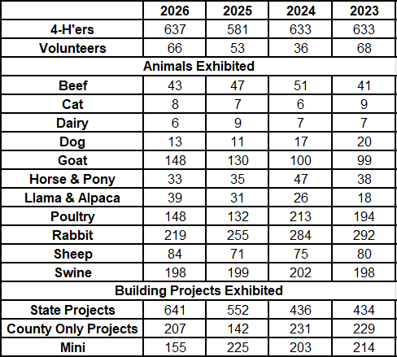

As the 2025 - 2026 4-H program year comes to a close, we reflect on the past year as we plan for the 2026-2027 4-H program year.
Youth reported they spent over 38,236 hours learning by doing and contributed over $691,047 to the local economy.
The future still looks bright to continue to develop youth.

Knox County 4-H Exhibitors at State Fair:

Althoff, Jayna
Althoff, Jon
Barrett, Mia
Baum, Brigston
Blubaum, Ellie
Blubaum, Taylor
Boyles, Kolten
Brown, Kynzlie
Candler, Lauren
Candler, Sullivan
Cardinal, Bennett
Cardinal, Bryson
Carter, Landon
Chesser, Lyla
Claycomb, Eva
Cockerham, Kallie
Cockerham, Katelyn
Cockerham, Kyle
Cook, Hunter
Davis, Brixton
Deckard, Alea
Decker, Adron
Decker, Chloe
Decker, Ryker
Dellinger, Lee
Detweiler, Grace
Duckworth, Bryn
Duckworth, Caleb
Dunn, Abigail
Dunn, Brantley
Dyer, Jocelyn
Ferguson, Samantha
Fields, Maya
Garretson, Avery
Garretson, Taylor Ann
Gilmore, Amy
Green, Connor
Green, Katie
Hammelman, Jeremiah
Hammelman, Moxon
Hammelman, Taylor
Hansen, Kolton
Harting, Amelia
Harting, Oliver
Hatcher, Angel
Heinz, Abigail
Hollis, Jillian
Holscher, Maebry
Holscher, Ross
Horrall, Maddy
Ingram, Aubree
Jacob, Audrey
Johnson, Luke
Johnson, Rylee
Keeton, Ella
Khurana, Arjun
Kixmiller, Gavin
Klem-Kixmiller, Kali
Krohn, Peyton
Lafferty, Kadie
Lane, Cora
Lane, Mason
Lane, Owen
Lavely, Nora
Lindsey, Lexie
Loudermilk, Ella
Loudermilk, Levi
Lynch, Meka
Misiniec, Alexis
Nettles, Brooklynn
Nettles, Caleb
Newton, Clayton
Newton, Hadley
Noland, Abby
Nowaskie, Sarah
Parker, Leigha
Quarterman, Colton
Quarterman, Kyndall
Reynolds, Kolten
Reynolds, Phebe
Rickard, Emilee
Rickard, Natalee
Roberts, Haley
Schopmeyer, Evelynn
Schopmeyer, Orrin
Short, Madelyn
Sprague, Isaiah
Sprague, Joshua
Stephens, Millie
Strohm, Zoe
Vieke, Maggie
Wells, Regan
Wolters, Adalin
Wolters, Hope
Wonning, Alli
Wonning, Brady

Congratulations to all those who competed at State Fair!

Sweepstake: Building Project:
- Ferguson, Samantha “Tomato”

Special Merit: Building Project:
- Candler, Sullivan “Woodworking”
- Carter, Landon “Entomology”
- Cockerham, Kallie “Tomato”
- Davis, Brixton “Farm Scene”
- Detwieler, Grace “Beekeeping”
- Ferguson, Samantha “Floriculture”
- Green, Katie “Genealogy”
- Hancock, Annie “Foods, Baked”
- Heinz, Abigail “Veterinary Science”
- Johnson, Luke “Tomato”
- McKinley, Finley “Muskmelon”
- Nowaskie, Sarah “Cake Decorating”
- Parker, Leigha “Sewing Construction”
- Ravellette, Karly “Garden 4 Plate”
- Rickard, Natalee “Beef Poster”

Special Merit: Building Project:
- Rickard, Natalee “Soil & Water Science”
- Sprague, Isaiah “Photography”
- Wolters, Adalin “Health”
- Wolters, Hope “Health”

Fashion Revue Honor Group:
- Wolter, Adalin “Separates”

Grand Champion Percentage Boer Doe:
- Newton, Clayton

Reserve Grand Champion Fullblood Boer Doe:
- Newton, Clayton

Breed Champions:
- Taylor Blubaum “Tamworth, Gilt”

Upcoming Dates

- 4-H Enrollment Begins: October 1!!
- National 4-H Week: October 4 – 10
- Tractor Supply Paper Clover: November 27 – December 13
- 4-H Enrollment push ENDS: January 15, 2027
- 4-H Scholarships “Senior Year & Accomplishment” DUE: January 25, 2027

Health & Human Sciences


Extension Homemakers—Updates

Several of the Knox County Extension Homemakers were busy in July with the Open Class Showcase at the Knox County Farm Fair in Bicknell. There were exhibits, demonstrations, kids’ crafts, watermelon crafts, quilt raffle, gourd lesson, noodle making lesson, fiber arts presentation, stash buster, silent auction…So much to experience in just that one building. Plan on joining them next year.
- At the July Council meeting it was discussed that Knox County will be hostess for the Spring 2027 Evansville Extension Homemakers District meeting. Officers are starting to plan for this event and will promote Knox County while they have homemakers from several counties visiting.
- September 14 will be the next council meeting at 10:30 in the Knox County Library sunroom. All members are welcome to attend.
- The Fall Evansville District meeting will be held in Vanderburgh County on Sept 30. The local club presidents will be getting more information soon.
- October 19-23 is IEHA week. The Knox County homemakers will decorate a window at the Knox County Library during October. Come see what they have to display.
Invitation to be involved:
- Anyone/Everyone is invited to become an Extension Homemaker. Purdue University Extension provides their knowledge for educational development. Clubs meet in their home or other locations convenient for the members, usually during the day. Contact Darlene Decker or Suzan Morgan for more details. Or contact the Extension Office with any questions at 812.882.3509.

ServSafe Manager course

ServSafe Manager Certification is an approved training course in the state of Indiana to become a certified food protection manager. This includes anyone who is the food service manager for a restaurant or other business and anyone who uses a shared commercial kitchen.

ServSafe Food Handler is for anyone else who needs basic food safety and food handling training, including home-based vendors, food service workers, volunteers, or others who work with food and only need the basic training. This course is NOT intended for food service managers.

To find and register for upcoming classes, visit https://edustore.purdue.edu/extension-programs.html, choose “HHS Events” then search by keyword, county and/or date. You may also contact Jennifer at 812-254-8668 or jstefanc@purdue.edu.

What | When | Where | Learn more or register at
ServSafe  Manager | October 22, 2026 | Washington | https://cvent.me/ZayAoO

Bite by Bite: Nutrition for Life Podcast

Anywhere you look you can find a magic pill or formula promising to protect your health and transform your body in three easy steps. And many of these claims do have (or at least started with) a speck of valid science. So, how do you cut through all the hype and separate truth from false marketing claims? The truth is, it doesn’t have to be that complicated! Join us as we explore and dissect different fads and trends to discover the real science behind food and nutrition.
Find us on Apple podcasts, Spotify, or anywhere you listen.

Follow us on Facebook and Instagram @BiteByBiteNutritionForLife

Agriculture & Natural Resources
Valerie Clingerman-Extension Educator
Agriculture & Natural Resources
clingerman@purdue.edu

**Like Purdue Extension Knox County Ag and Natural Resources on Facebook.
**To receive monthly e-newsletters call 812-882-3509 or e-mail me to be added.


Upcoming Events
Date | Event | Time (Eastern) | Location | Contact info.
Sept. 12 | Farm Vitality Workshop | 9 am | Boonville | Megan.klenck@in.nacdnet.net
Sept. 16 and 30 | Collaborative Food Systems-business planner for co-ops and collaborative land ownership | 1 pm  2 pm | Webinar | https://tinyurl.com/INfarmcoop
Sept. 19 | Wild About Nature Series-Birds  (see below) | 10 am | Vincennes | Register by calling:  812-882-4316
Sept. 26 | Monarch Madness (pg. 8) | 11am-2 pm | Vincennes | 812-882-8210
Oct. 6 | Land of Opportunity, A Conference for Farmland Owners | 8:15 am | Terre Haute | 765-653-8411 register at https://tinyurl.com/LandofOpportunity26
Dec. 11 | Agriculture Outlook and PARP | 8:00 am | Vincennes | 812-882-3509

Wild about Nature Series
Adobe Stock Image

I am excited to partner with the Knox County Parks Department to offer hands-on activities about nature. We will have programs monthly from May-Sept. and will be meeting at County Parks. Our final program will be in September so don’t miss out!

September 19-Ouabache Trails Nature Center, 10am, learn about birds while viewing them and create your own bird feeders to take home.

Please register with the Parks Department by calling 812-882-4316.

Monarch Madness
Join us at Fox Ridge Nature Park (1364 N Hillcrest Rd. Vincennes) on September 26th from 11:00am-2:00pm for a free family event.
Participants will get an opportunity to catch monarchs and learn how to identify their gender and participate in university research projects to track monarch movement and learn about parasites that live on them.
There will be kid’s activities, free food and drinks, and vendors.

Survey of August 2026: Making or Breaking Field Crops?
Shaun Casteel, Purdue University

The 2026 growing season started and continues with intense rain events that dropped 3 to 6 inches in a single day, which was impressive in its own right. Unfortunately, these intense storms have continued all season long. Historic rains and floods settled across many counties of Indiana in the past few weeks with single events dumping 8 to 15 inches of rain. The effect on corn and soybeans at this point of the season is unchartered waters.

Please take a few minutes to fill out the survey to provide insight to the impact to your fields/area and distribution of the extreme weather in August 2026. The survey can be found at: https://purdue.ca1.qualtrics.com/jfe/form/SV_3Xid0TER5lkf4jk or use the QR code below.

We welcome all responses from those who were fortunate to get timely rains to those affected by straight line winds to those in the epicenter of historic floods. We would like to partner with you to track crop response to this historic weather. If you would like assistance in the field, you can provide your contact information at the end of the survey (closes August 31st).

If you have agriculture damage, contact the local USDA Farm Service Agency (www.fsa.usda.gov/fsa-office-locator).

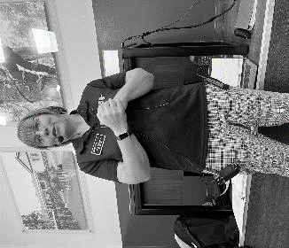
Guatemala Drone Program

In July, Valerie Clingerman (Ag and Natural Resource Educator (ANR)- Region 8) and Heidi Potter (ANR Region 12) traveled to Guatemala to deliver a week-long drone training to 45 people from the Guatemalan Ministry of Agriculture’s Surveillance Team. This was the 4th project in an ongoing USDA Ag Trade and Climate Smart Innovations grant. One goal of this grant is to increase capacity to use drone technology in horticulture crops in order to reduce the quantity of produce rejected for export due to phytosanitary contamination.
Image courtesy of Heidi Potter: Valerie Clingerman teaching classroom sessions in Guatemala
The drone training took place at the National Central School of Agriculture where they grow a wide variety of crops: avocado, macadamia, banana, coffee, maize, and many vegetables. The first two days focused on the safe and efficient operation of drones. Training combined lecture, small group discussion, and hands-on activities using Virtual Reality and drones. The final three days focused on advanced techniques such as camera settings, planned/autonomous flights, interpreting plant health maps, and GIS. In addition to Purdue staff, Central American partners assisted with classroom instruction and in-field flights. Additionally, the Minister of Agriculture, Livestock and Food attended a portion of the training.
Participants were eager to learn and apply their knowledge. Evaluation results showed strong outcomes in knowledge gain as well as increased confidence in using drones to more effectively and efficiently perform surveillance work. One participant commended, “This is the first training where we’ve actually learned something and put it to use. This is an experience I won’t forget!”

If you or your company has employees needing to take their FAA remote pilot exam, we have a training that helps study for the part 107 exam. Contact Valerie Clingerman at the Knox County Extension Office for details. Call 812-882-3509 or email clingerman@purdue.edu.
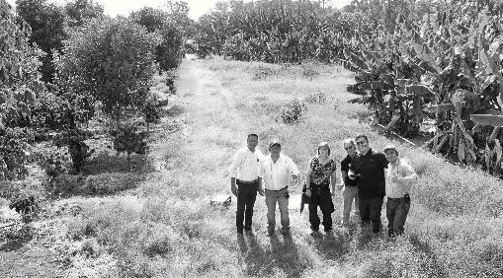

Image courtesy of Heidi Potter: Valerie Clingerman and Heidi Potter overseeing practice drone flights in the field


ocust, and poplar are labelled as
Nonprofit Organization
U.S. Postage
PAID
Vincennes, IN
Permit No. 39
Purdue University Cooperative Extension Service
Knox County
4259 North Purdue Rd.
Vincennes, IN 47591

Nonprofit Organization
U.S. Postage
PAID
Vincennes, IN
Permit No. 39

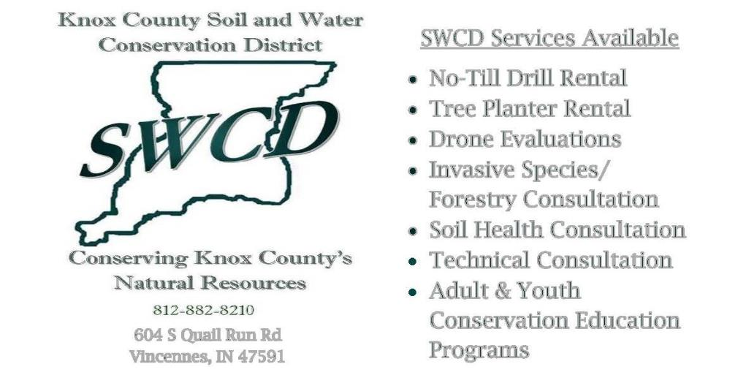
Thank you for your support!
Look inside for Agriculture & Natural Resource, Health and Human Science, and 4-H updates

