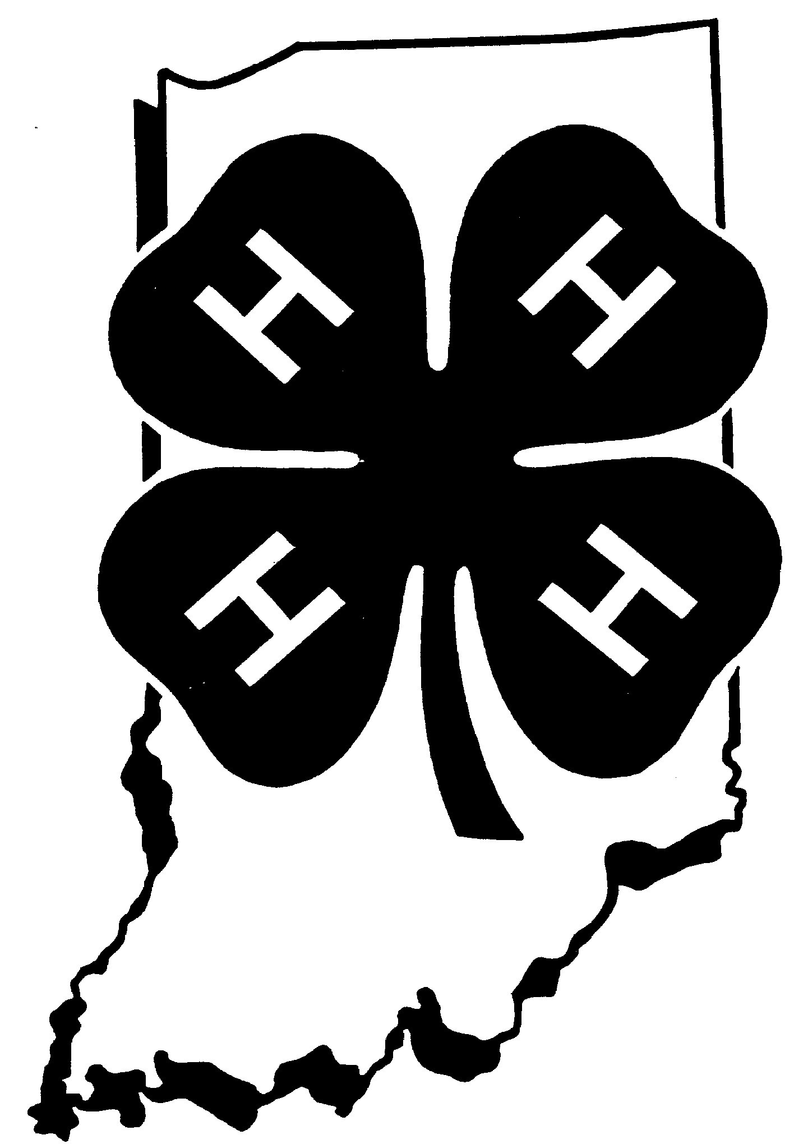
4-H Foods Recipe Card

Name Project Level A B C D
(circle level)

Class County

Name of Product

Ingredients

(Continue on back if needed)
______________________________________________________________________________
4-H Foods Recipe Card

Name Project Level A B C D
(circle level)

Class County

Name of Product

Ingredients

(Continue on back if needed)

