**Posey County 4-H FairEntry** works in cooperation with 4-H Online, so you will use the same username and password as 4-H Online. Families will use FairEntry to pre-enter projects for the fair. This program will be used to create project labels, check in sheets, judging sheets, show programs, media reports, ribbon placings, award placings and more.

**Please enter projects for the Posey County 4-H Fair by June 15.** For projects by grade level you will use the grade you were enrolled in as of January 1. The 4-H projects will be listed under a specific Department. The following is a guide to help you find projects in FairEntry.

[**http://poseycountyindiana.fairentry.com/**](http://poseycountyindiana.fairentry.com/)

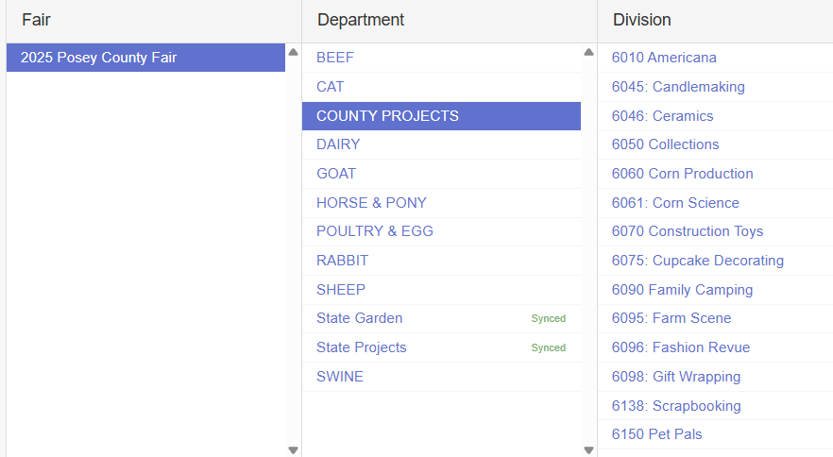

**Department: County Only Projects**

* Americana
* Candlemaking
* Ceramics
* Collections
* Corn Production
* Corn Science
* Construction Toys
* Cupcake Decorating
* Family Camping
* Farm Scene
* Fashion Revue (Grades 3-7)
* Gift Wrapping
* Scrapbooking
* Pet Pals
* Recycling
* Soybean Production
* Soybean Science
* Sports
* Travelogue
* Mini 4-H (Exhibit Building entries)

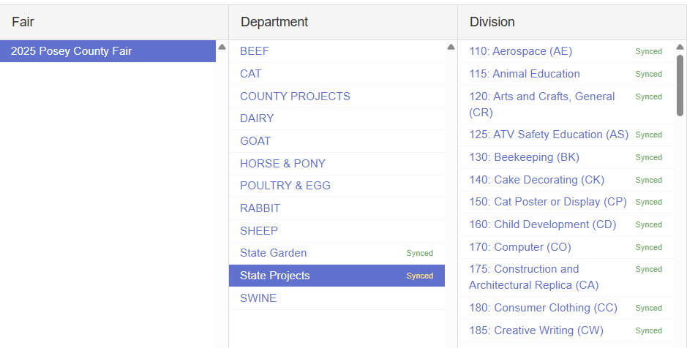

**Department: State Projects**

* Aerospace
* Animal Education (Beef, Dairy, Goat, Horse, Sheep, & Swine Posters)
* Arts and Crafts, General (**Not** Fine Arts, Model Craft, or Needle Craft)
* Beekeeping
* Cake Decorating
* Cat Poster
* Child Development
* Computer
* Consumer Clothing
* Creative Writing
* Dog Poster
* Electric
* Entomology
* Fashion Revue (Grades 8-12)
* Fine Arts
* Floriculture
* Foods, Baked
* Foods, Preserved
* Forestry
* Genealogy
* Geology
* Health
* Home Environment
* Lawn and Garden Tractor Operator Skills (Tractor Operator Contest)
* Model Craft
* Needle Craft
* Photography
* Poultry Poster
* Rabbit Poster
* Sewing Construction (Wearable and Non-Wearable)
* Small Engines
* Soil and Water Science
* Sport Fishing
* Tractor Operator Skills (Tractor Operator Contest)
* Tractor Safety Education (Ag Tractor Poster)
* Veterinary Science
* Weather and Climate Science
* Wildlife
* Woodworking
* Zero-Turn Radius Mower Operator Skills (Tractor Operator Contest)

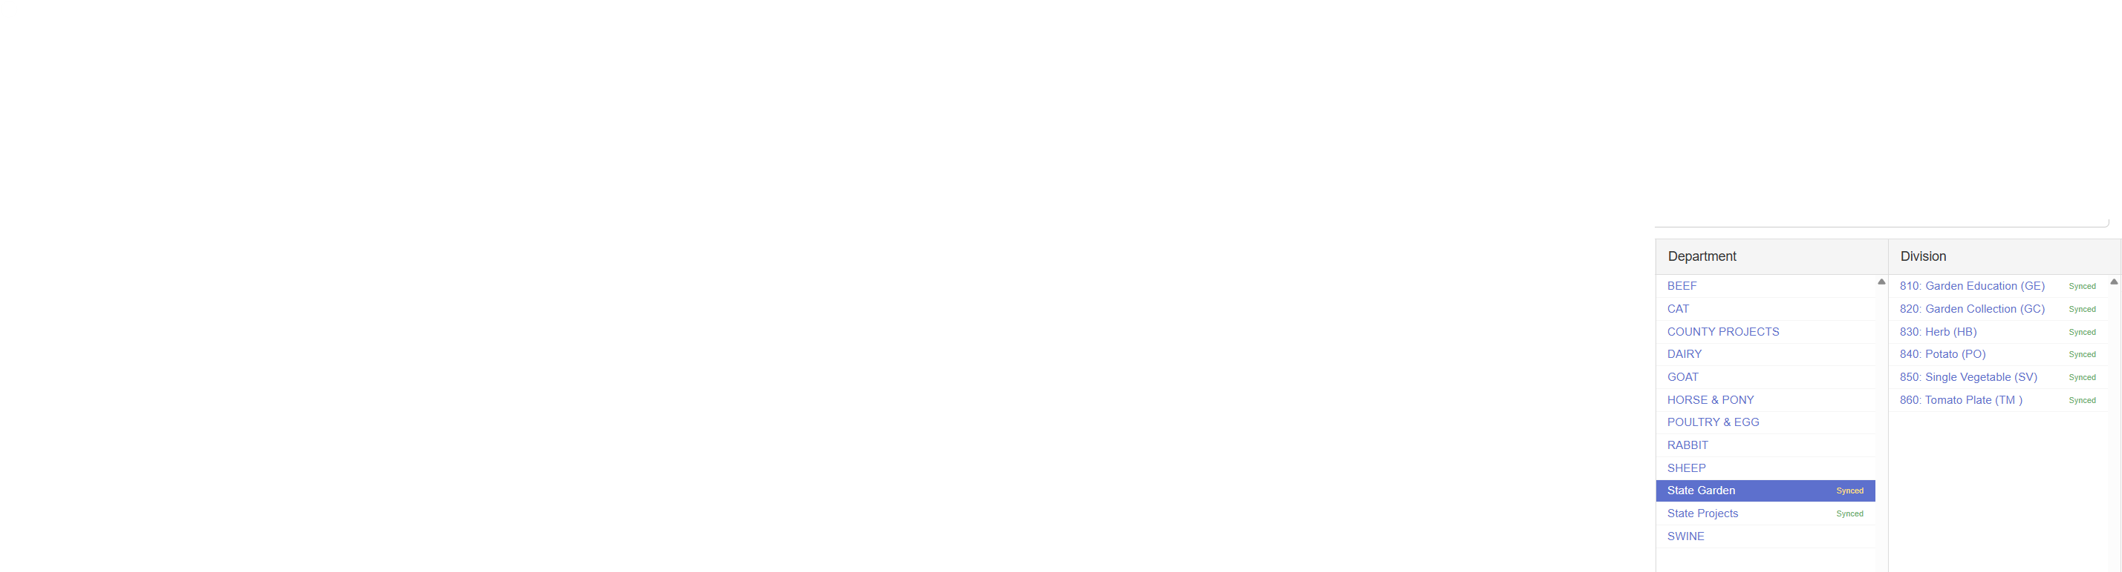

**Department: State Garden**

* Garden Education (Poster)
* Garden Collection
* Herb
* Potato
* Single Vegetable
* Tomato plate

**Other Departments:**

**Beef Cattle –** All classes & Mini 4-H Beef

**Cat –** All classes & Mini 4-H Cat

**Dairy Cattle** – All classes & Mini 4-H Dairy

**Goats –** All Classes & Mini 4-H Goat

**Horse & Pony** – All Classes & Mini 4-H Horse &Pony (under select Western Divisions)

**Poultry & Egg –** All Classes & Mini 4-H Poultry

**Rabbits –** All Classes & Mini 4-H Rabbit

**Sheep –** All Classes & Mini 4-H Sheep

**Swine –** All Classes & Mini 4-H Swine