2023

Warrick County 4-H

Achievement Awards

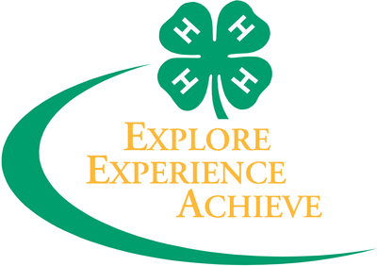

2024
Warrick County
4-H Trip Winners
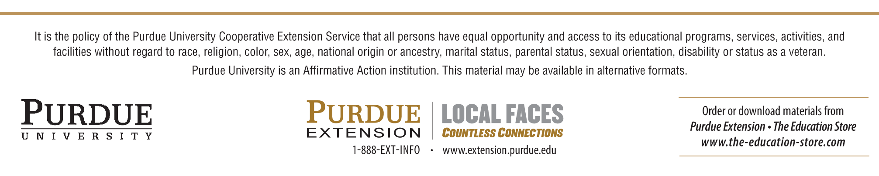
PHILOSOPHY OF AWARDS GIVEN AT ACHIEVEMENT PROGRAM

We believe in rewarding 4-H members for their efforts in many different ways. The incentive most 4-H members are familiar with is a receiving a ribbon and/or trophy during Warrick County Fair week for an exhibit submission. However, the core of the incentive program seeks to reward the knowledge and skills found through a particular 4-H project, activity or program highlighting what they have learned in the project, as well as how it was learned. The purpose of the Achievement Awards is to reward the growth of project requirements and/or the pursuit of one phase of an activity for deeper understanding. The Awards Committee meet several times the previous fall to select achievement pin and trip recipients. Achievement pins are given in each project for a 4-H member’s achievement during that particular year. Project achievement pins are awarded on the basis of one pin for every ten-project exhibit and/or completions. Trips are awarded on a project completed/age/grade combination to meet both county and state guidelines. Selection is based upon work done by the 4-H member in an individual project as shown by the White Achievement Card “My Record of 4-H Achievement”.

Selection of these awards are made first from the evaluation of (1) Information learned reported on the front of the card and then: (2) Project work reported on the front of the card (3) Demonstrations given (4) Judging activities completed (5) Committee Work (6) Meetings/Workshops attended (7) Community Service (8) Leadership demonstrated and (9) Other 4-H activities.

The Warrick County Purdue Extension employees, 4-H Council and the Awards Committee reviewed the requirements for awards.

We have put forth our best efforts in proofreading, which includes double-checking all 4-H members’ names to make sure we have the correct spelling. However, we are human after all, and apologize in advance if there is some mishap. Please let the office know and we will be glad to provide you another copy of the book or program as a keepsake with correct spelling.

Thank you!
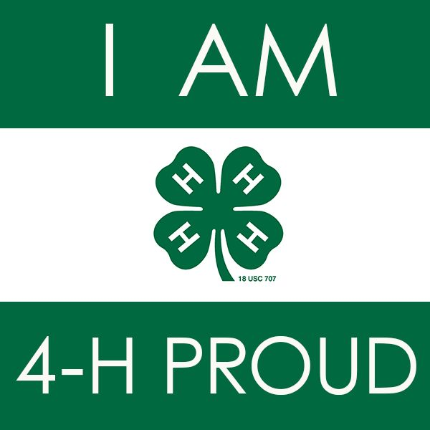

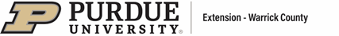

Queen Escorts:
Kie Silke
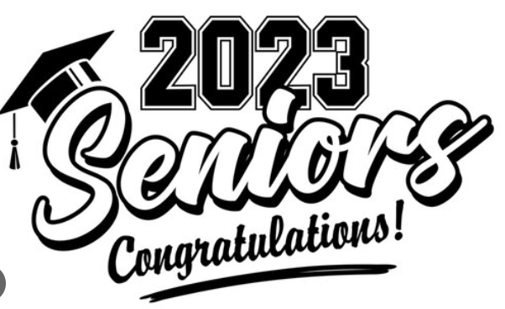

Cooper Aigner
Piper Angel
Garrett Arnold
Olivia Barr
Annabelle Barsumian
Elijah Biggins
Joshua Biggins
Grace Blondin
William Bracher
Alexa Cecil
Macon Davis
Russell Evans
Briston Gates
Owen Heim
Russel Heim
Vivian Hess
Alexandra Hill
Easton King
Jenna Kroeger
Markie Lance
Corben Lashley
Pennelope Lemen
Joshua McCool
Dylan Robbins
Kie Silke
Elijah Smith
Gavin Smith
Robbie Snelling
Ethan Spindler
Abigail Stallings
Emma Stevens
Jackson Tuley
Brittney Wahl
Landon Wilder
Andrew Yager
Brady Yager
Conner Yager
Grant Yager

2023 ACHIEVEMENT PIN WINNERS

AGRICULTURE PROGRAM
These awards are presented for combined project work done in the Agricultural Projects during the 2023 4-H year.

Matthew Davis Franklin Fox Emory Foster Desie Potts
Morgan Davis Rosalind Kidwell Alayna Horn
Andi Allen Maggie Barr Abigail James
Annabelle Fox Olivia Barr Delanie Potts

LIVESTOCK PROGRAM
These awards are presented for combined project work done in the Livestock Projects during the 2023 4-H year.

Matthew Davis Morgan Davis Andi Allen Annabelle Fox
Franklin Fox Rosalind Kidwell

LIVESTOCK and COMPANION ANIMAL PROJECTS

BEEF:
Morgan Davis
Matthew Davis
Rosalind Kidwell
Colten Lashley

CAT:
Delanie Potts
Desie Potts

DAIRY:
Andi Allen

DOG:
Alayna Horn
Abigail James

GOAT:
Andi Allen
Annabelle Fox
Franklin Fox

HORSE & PONY:
Alayna Horn
Morgan Silke

POULTRY and EGGS:
Maggie Barr
Olivia Barr
Emory Foster

RABBIT:
Tucker Eden
Campbell Wallace
Ella Montgomery
Claire Montgomery
Delanie Potts
Desie Potts

SHEEP:
Hailey Higgs

SMALL PETS:
Nikki Kelle

SWINE:
Wyatt Kidwell
Wyatt Nolan
Lyla Schmitt
Morgan Silke

VET SCIENCE:
Emory Foster

SMALL COMPANION ANIMALS PROGRAM
These awards are presented for combined project work done in Small Companion Animal Projects during the 2023 4-H year.

Maggie Barr Olivia Barr Emory Foster Alayna Horn
Abigail James Delanie Potts Desie Potts

FIELD CROPS PROGRAM
This award is presented for combined project work done in the Field Crop projects during the 2023 4-H year.

Claire Mosbey Henry Mosbey

FIELD CROPS INDIVIDUAL PROJECTS
These awards are presented for work done in the individual projects of Field Crops during the 2023 4-H year.

CORN: HAY: SOYBEANS
Henry Mosbey McCormick Clark Claire Mosbey
Henry Mosbey

HORTICULTURAL PROGRAM
These awards are presented for combined project work done in the Horticultural Projects during the 2023 4-H year.

Abigail Stallings Calvin Stallings Evelyn Stallings

HORTICULTURE PROJECTS
These awards are presented for work done in the individual projects of the Horticulture projects during the 2023 4-H Year.

FLORICULTURE: GARDEN: HERBS:
Evelyn Stallings Eli Boyle Morgan Silke
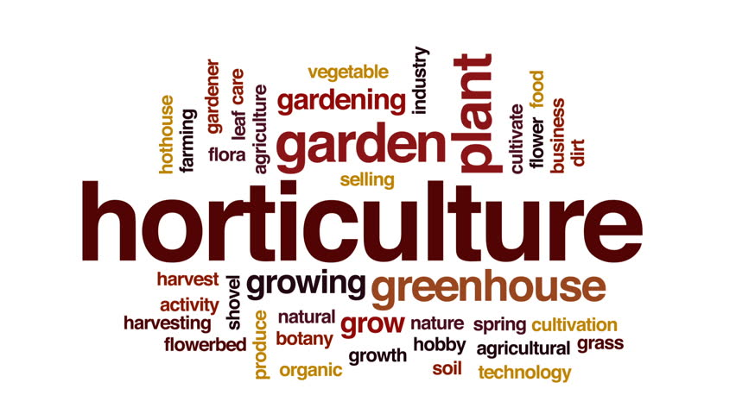
Evelyn Stallings
Calvin Stallings
Abigail Stallings
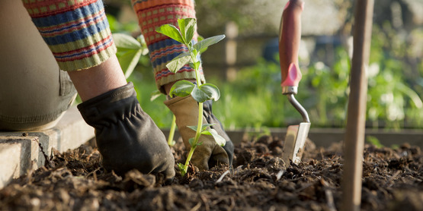

ENGINEERING & SCIENCE PROGRAM
These awards are presented for combined project work done in the Engineering & Science Projects during the 2023 4-H year.

Kael Fields Franklin Fox Evelyn Stallings
Samantha Kloeck Dawson Merkel Nolan Plewke
Delanie Potts Isaac Neireiter Annabelle Fox
Calvin Stallings Desie Potts Abigail Stallings

ENGINEERING & SCIENCE PROJECTS
These awards are presented for work done in the individual projects of the Engineering & Science Program during the 2023 4-H Year.

AEROSPACE:
Nolan Plewke
Matthew Davis

COMPUTER SCIENCE:
Isaac Neireiter

ELECTRIC:
Franklin Fox
Annabelle Fox
Calvin Stallings

ELECTRIC ARC WELDING:
Franklin Fox

Entomology:
Samantha Kloeck

GEOLOGY:
Calvin Stallings

HEALTH:
Samantha Kloeck

MODELS:
Ruie Robinson
Calvin Stallings

RECYCLING:
Samantha Kloeck
Zachary Fuquay

PHOTOGRAPHY:
Desie Potts
Lilly Young
Audra Wigger
Abigail Stallings
Tucker Eden
Isaac Neireiter

SHOOTING SPORTS:
Annabelle Fox
Franklin Fox
Levi Graham

SMALL ENGINES:
Andrew Yager

ATV
Callahan Merkel

TRACTOR/LAWN/ZERO TURN:
Corbin Creek
Morgan Davis

WEATHER:
Samantha Kloeck

WOODWORKING:
Zayden Seger
Evelyn Lance
Dawson Merkel
Wyatt Kinman

PETROLEUM POWER PROGRAM
This award is presented for work done in the individual projects of the Petroleum Power Program the 2023 4-H Year.

Kael Fields

STATE ELECTRIC AWARDS
These awards are presented for work done in the Electric Project during the 2023 4-H year.

DIVISION I: Wire Stripper:
Dawson Merkel

DIVISION II 13in1 Screwdriver:
Nolan Plewke

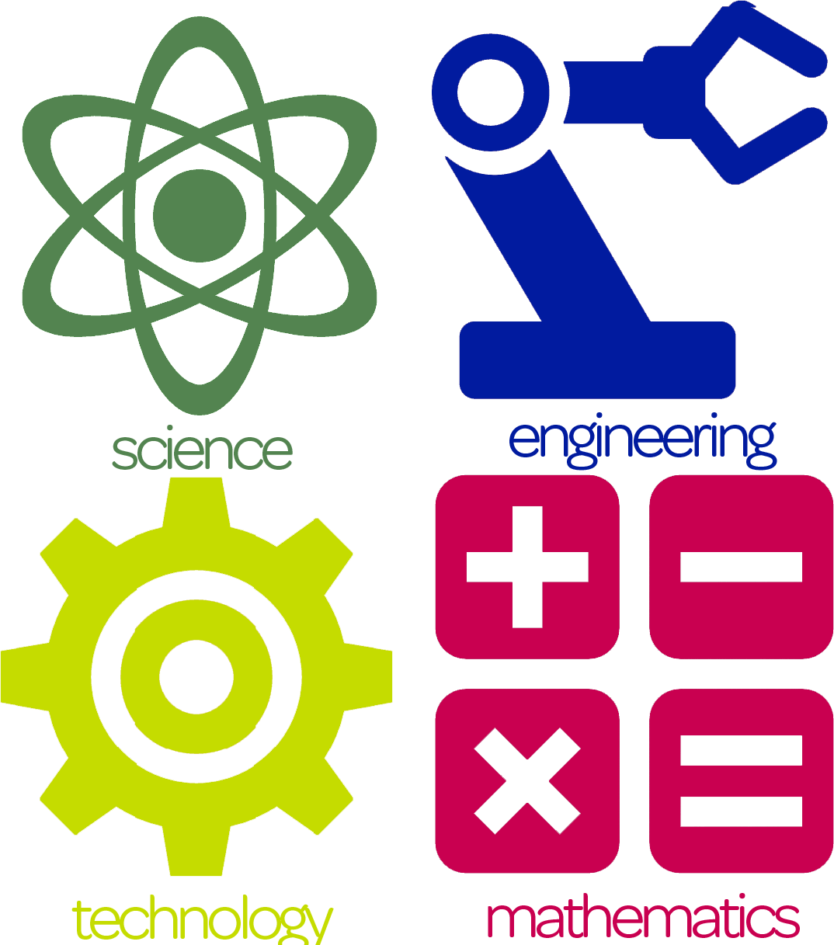
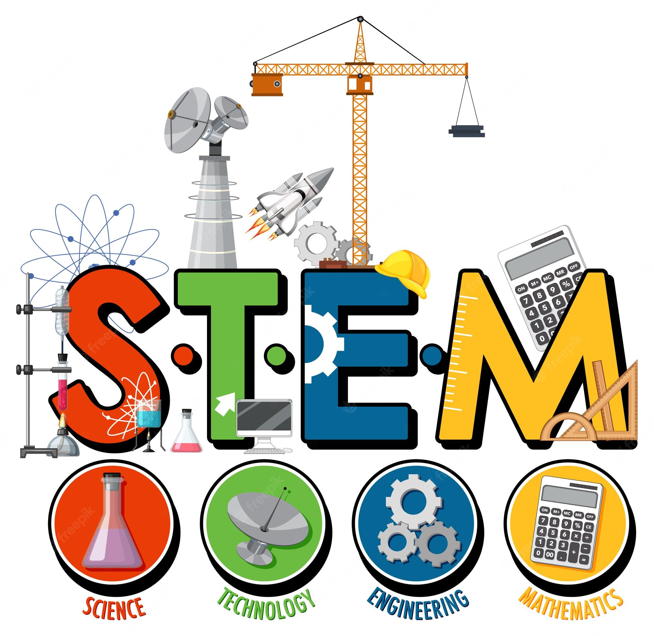
DIVISION III: Voltage Sensor:
Kael Fields

DIVISION IV: Multi-lighted receptacle tester:
Franklin Fox

ADVANCE ELECTRIC:
Digital Multimeter:
Annabelle Fox
Evelyn Stallings

CONSERVATION PROGRAM
This award is given for combined project work done in the Conservation projects during the 2023 4-H year.

Samantha Kloeck Abigail Stallings Evelyn Stallings

CONSERVATION PROJECTS
These awards are presented for work done in the individual projects of the Conservation Program the 2023 4-H Year.

BEEKEEPING:
Evelyn Stallings

FORESTRY:
Samantha Kloeck

SOIL & WATER CONSERVATION:
Abigail Stallings
SPORTS FISHING:
Emma Heim

WILDLIFE:
Samantha Kloeck

PERSONAL DEVELOPMENT PROGRAM
These awards are given for combined project work done in the Personal Development Projects during the 2023 4-H year.

Samantha Kloeck Calvin Stallings Delanie Potts
Abigail Stallings Evelyn Stallings Desie Potts

PERSONAL DEVELOPMENT PROJECTS
These awards are presented for work done in the individual projects of the Personal Development Program during the 2023 4-H Year.

ABE LINCOLN:
Delanie Potts

AMERICANA:
Samantha Kloeck

CITIZENSHIP:
Abigail Stallings

COLLECTIONS:
Samantha Kloeck

COMMUNICATIONS:
Franklin Fox

CREATIVE WRITING:
Samantha Kloeck

FARM TOY SCENE:
Calvin Stallings
Levi Graham

GENEALOGY:
Rosalind Kidwell

LEADERSHIP:
Abigail Stallings

MUSIC:
Samantha Kloeck

RECREATIONAL SPORTS:
Samantha Kloeck

SCRAPBOOKING:
Abigail Stallings

CONSUMER & FAMILY SCIENCE PROGRAM
These awards are presented for work done in the individual projects of the Consumer & Family Sciences Program during the 2023 4-H year.

CAKE DECORATING:
Samantha Kloeck
Claire Montgomery

CHILD DEVELOPMENT:
Abigail Stallings

CONSUMER CLOTHING:
Paige Neireiter

CREATE-A-MIX:
Samantha Kloeck
Abigail Stallings

CONSTRUCTION AND ARCHITECT-
URAL REPLICA:
Samantha Kloeck
Aubrey Buxton

FOODS:
Samantha Kloeck
Desie Potts
Delanie Potts
Claire Montgomery
Raelynn Mutschler
Abigail Stallings

HOME ENVIRONMENT:
Ella Montgomery

SEWING:
Claire Montgomery
Reese Heim

HOME ECONOMICS PROJECTS
These awards are presented for combined project work done in the Consumer & Family Science Projects during the 2023 4-H year.

Maggie Barr Olivia Barr Vera Cummins Reese Heim
Samantha Kloeck Delanie Potts Desie Potts Claire Montgomery
Ella Montgomery Paige Neireiter Abigail Stallings Evelyn Stallings

ARTS & CRAFTS PROJECTS

These awards are presented for work done in the individual projects of the Arts & Crafts Program during the 2023 4-H year.

Evelyn Stallings Delanie Potts Desie Potts Ella Montgomery
Corben Lashley Carter Corbin Vera Cummins Wyatt Kinman
Maggie Barr Olivia Barr Samantha Kloeck

2023 JR. LEADER ORGANIZATION COMPLETION
Maggie Barr Olivia Barr Abigail Stallings Caden Buxton
Adelynne Plewke Evelyn Stallings Leland Fox Nyle Bush
Luke Pryor

2023 HONOR CLUB

The Honor Club’s objective is to recognize 4-H Clubs and its members by establishing criteria which promote engagement, excellence, and active participation in 4-H activities throughout an established period. Thus, the Warrick County 4-H Council has established “Honor Club” to recognize those local 4-H Clubs that excel in local and county 4-H activities during a given year. They are meant to encourage Clubs to participate in all the opportunities available to them.
The Honor Club Award will be awarded to EACH Club that does fifteen (15) recommended activities. Following the County 4-H Fair, any local Club that feels it has met the criteria for the award will be asked to complete a record of activities. This year, we recognize the following:

Castle Community Degonia Community Builders

NATIONAL LEADERSHIP

“I DARE YOU AWARD”

The “I Dare You” award is presented by the Ralston Purina Company to a young man or a young woman in the 4-H program who is a Junior in high school and has shown leadership based on balanced personal development. This award includes a book and certificate.
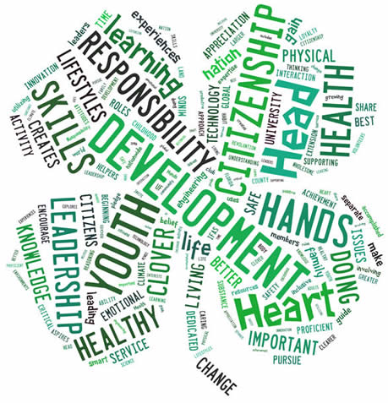
Ranked in Order by Committee:

Evelyn Stallings (alt. Annabelle Fox)

CAREER AWARDS

Awarded only to those 4-H’ers 16 years of age and older. These awards can only be received once during their 4-H career. They are awarded based upon evaluation of all the work done throughout their time in 4-H.

ACHIEVEMENT: Trophy/Medal LEADERSHIP: Plaque/Medal
Olivia Barr Rosalind Kidwell
Corben Lashley

CITIZENSHIP: Plaque/Medal
Delanie Potts
Evelyn Stallings

NATIONAL 4-H CONFERENCE
April 19-24, 2024
Adelynne Plewke
Evelyn Stallings

STATE 4-H JUNIOR LEADER CONFERENCE
TBA
Delegates:
Maggie Barr Addison Heilman
Wyatt Kidwell Evelyn Stallings

4-H ROUND-UP
June 24-26, 2024

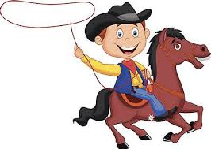
Delegates:
Franklin Fox
Levi Graham
Samantha Kloeck
Madelynn Nicodemus
Desie Potts
Levi Pryor
Calvin Stallings
Elizabeth Wahl

4-H ACADEMY WORKSHOPS at PURDUE UNIVERSITY

TRIP WINNERS AND ALTERNATES
June 12-14, 2024

ANIMAL SCIENCE: ANIMAL BIO-SCIENCE

Delegate: Addison Heilman
Emma Heim

ANIMAL SCIENCE: ANIMAL HEALTH

Delegate: Morgan Davis

CITIZENSHIP: COMMUNITY CHANGE

Delegate: Evelyn Stallings Alternate: None

COMPUTER SCIENCE

Delegate: None Alternate: None

ELECTRIC

Delegate: None Alternate: None

ENGINEERING OUR ENVIRONMENT

Delegate: Annabelle Fox Alternate: None

EXPLORING HEALTH CAREERS

Delegate: None Alternate: None

FOOD ANIMAL

Delegate: Wyatt Kidwell Alternate: None
Cole Kirsch

INTRO TO EMS (Emergency Medical Services)

Delegate: None Alternate: None

NATURAL RESOURCES

Delegate: None Alternate: None

PLANT SCIENCES

Delegate: None Alternates: None

THE SCIENCE OF FLIGHT

Delegate: Matthew Goff Alternate: None

If a 4-Her cannot take the trip he/she is awarded and does not notify the Extension Office that they will not be taking the trip PRIOR to March 1, 2024 and a replacement is not found, the 4-H member will be required to reimburse the 4-H Council for the amount of the trip and transportation fees, if applicable. This includes all State and National trips, as well as, 4-H Choir and 4-H Band. A signed behavior form and acceptance or a non-acceptance of trip must be on file at the Warrick County Extension Office for each trip.

2023 WARRICK COUNTY
4-H FAIR HIGHLIGHTS
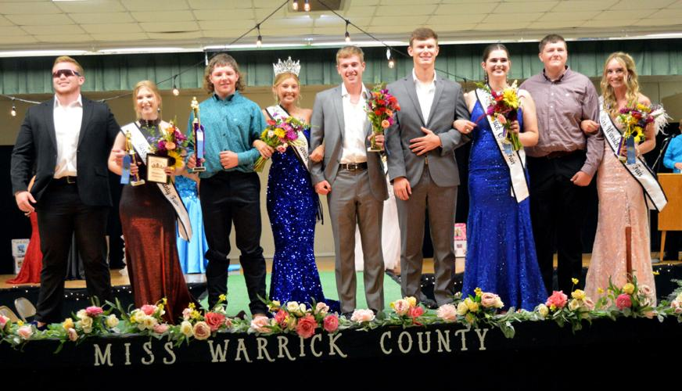
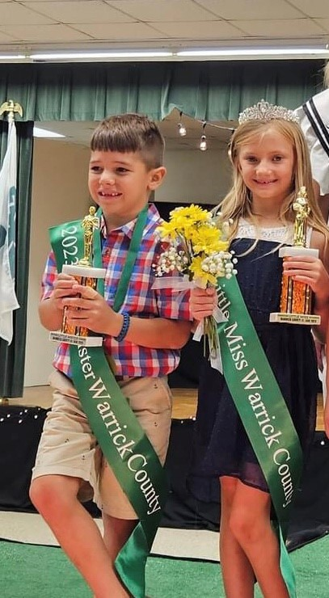
Little Miss: Jenna Tuley
2023 Queen: Jenna Kroeger
1st Runner-Up: Rosalind Kidwell
2nd Runner-Up: Olivia Barr
3rd Runner-Up: Jenna Smith

Candidates: Olivia Barr, Alexa Cecil, Addison Heilman, Abigail James, Rosalind Kidwell, Jenna Kroeger, Maya VanPolen and Jenna Smith.

Queen Escorts: Kie Silke, Gavin Smith, Landon Wilder, Mason Davis and William Bracher

Little Mister: Aiden Hess

